Accepting All Formatting Changes
by Allen Wyatt (last updated June 7, 2014)
Graciela has a huge document with many changes that were made with Track Changes turned on. Some of these changes are formatting changes and some of them are of other types, such as textual edits. Graciela would like to accept all the formatting changes but not the other types of changes. She is curious of there is an "accept all" command that will accept only the formatting changes.
It is relatively easy to accomplish this task. Just follow these steps:
- Make sure the Review tab of the ribbon is displayed.
- Click the Show Markup tool (in the Tracking group). Word displays some options that control what changes are shown.
- Clear all the checkmarks, except the Formatting checkmark. (You will need to repeat step 2 for each checkmark you need to remove.)
- Click the down-arrow under the Accept tool (in the Changes group). Word displays some different ways you can accept changes.
- Choose Accept All Changes Shown. All the formatting changes (which is all that are shown) are accepted. (Don't select Accept All Changes in Document; that would accept all the changes whether they are shown or not.)
- Use the Show Markup tool to select which changes you want Word to show.
If you find yourself getting rid of the formatting changes quite a bit, you can instruct Word to not track formatting changes at all. Follow these steps if you are using Word 2007 or Word 2010:
- Make sure the Review tab of the ribbon is displayed.
- Click the down-arrow under the Track Changes tool (in the Tracking group) and then click Change Tracking Options. Word displays the Track Changes Options dialog box. (See Figure 1.)
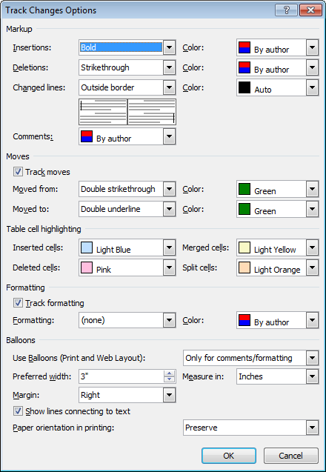
Figure 1. The Track Changes Options dialog box.
- Clear the Track Formatting check box.
- Click OK.
If you are using Word 2013, follow these steps instead:
- Make sure the Review tab of the ribbon is displayed.
- Click the small icon at the lower-right corner of the Tracking group. Word displays the Track Changes Options dialog box.
- Click the Advanced Options button. Word displays the Advanced Track Changes Options dialog box. (See Figure 2.)
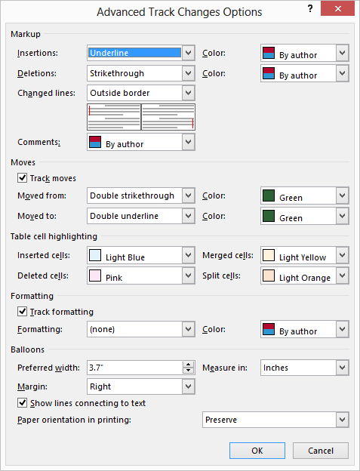
Figure 2. The Advanced Track Changes Options dialog box.
- Clear the Track Formatting check box.
- Click OK to close the Advanced Track Changes Options dialog box.
- Click OK to close the Track Changes Options dialog box.
Now Word won't track any of the formatting changes you make in the document. If you find that the setting is not persistent from one Word session to another, you can create a small macro to run whenever a document is opened. Simply add this single line to the macro:
ActiveDocument.TrackFormatting = False

