Applying Bullets from the Keyboard
If you press Ctrl+Shift+L, Word is supposed to automatically apply the predefined List Bullet style to your paragraph. To remove bullets, you could also use the Ctrl+Shift+N shortcut, which applies the Normal style.
While these may work for what you want done, they don't take the same approach to formatting as the Bullets tool on the Home tab of the ribbon. If you want to have that same functionality from the keyboard, you must customize your keyboard. Follow these steps:
- Display the Word Options dialog box-- File tab of the ribbon and then click Options.
- At the left side of the dialog box click Customize Ribbon.
- Click the Customize button, near the bottom-left of the dialog box. Word displays the Customize Keyboard dialog box. (See Figure 1.)
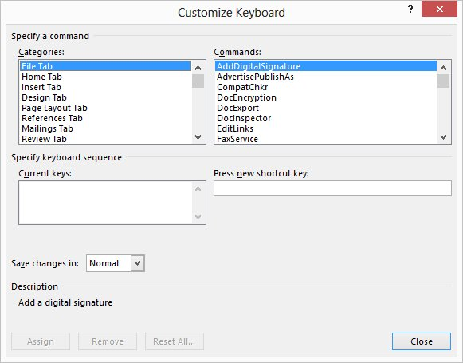
Figure 1. The Customize Keyboard dialog box.
- In the Categories list, choose All Commands.
- In the Commands list, choose FormatBulletDefault. (You'll need to scroll down quite a ways.)
- Click in the Press New Shortcut Key box.
- Press the keystroke you want to use to apply bullets. Alt+B is a good choice, since it is not in use on a default Word system.
- Click on Assign.
- Click on Close to dismiss the Customize Keyboard dialog box.
- Click on Cancel to close the Word Options dialog box.
Now, whenever you press the keystroke you chose in step 4, it is the same as clicking on the Bullets tool. Press the keystroke again, and the bullets are gone.

