Assigning a Macro to a Shortcut Key
Word allows you to assign macros or commands to specific key combinations. These key combinations are referred to as shortcut keys, and when used they result in the macro or command being executed. When you first create a macro by recording it, Word gives you the opportunity to assign the macro to a specific key combination. If you later want to change the key combination, you can follow these steps:
- Display the Word Options dialog box. In Word 2010 and Word 2013 display the File tab of the ribbon and then click Options.
- At the left side of the dialog box click Customize Ribbon.
- Near the bottom of the dialog box click the Customize button. Word displays the Customize Keyboard dialog box. (See Figure 1.)
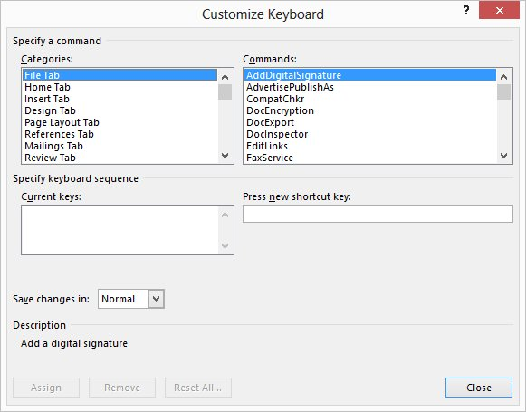
Figure 1. The Customize Keyboard dialog box.
- Scroll through the Categories list and select the Macros category. The list at the right side of the dialog box changes to show the currently available macros.
- In the Macros list, select the macro you want assigned to the shortcut key.
- With the insertion point in the Press New Shortcut Key box, press the shortcut key you want to use. For instance, if you want to use Ctrl+Alt+J, press that.
- Just below the Current Keys box you can see whether the shortcut key is already assigned to a different function.
- Click on Assign.
- Repeat steps 5 through 8 for each change you want to make.
- Click on Close.

