Automatically Adding Tabs in Footnotes
For some formatting purposes, you may have a need for Word to place a tab character in your footnotes, between the actual footnote reference number and the text of the footnote. Word does not allow you to do this automatically, however. In fact, Word doesn't allow you to specify what character should appear between the footnote reference number and footnote text, as you can with numbered lists. Instead, Word places a space between these two elements.
There are several ways you can go about making sure that the footnote includes a tab separator, and the various methods will be described shortly. All of the methods assume, however, that you have the Footnote Text style set up to handle the tab properly.
Whenever you insert a footnote, Word formats the footnote itself so that it uses the built-in Footnote Text style. You can control how the footnote appears by simply making changes to this built-in style. For instance, if you want a tab character between the footnote reference number and the beginning of the footnote text, then you should set a tab stop in the Footnote Text style so that Word knows what to do with the tab character once you get it in the footnote. Exactly how you modify styles has been covered in other issues of WordTips.
The first potential solution to adding the tabs is to use Word's Find and Replace feature. You can make sure that all footnotes have the requisite tab character by following these steps:
- Press Ctrl+H. Word displays the Replace tab of the Find and Replace dialog box.
- If available, click on the More button. (See Figure 1.)
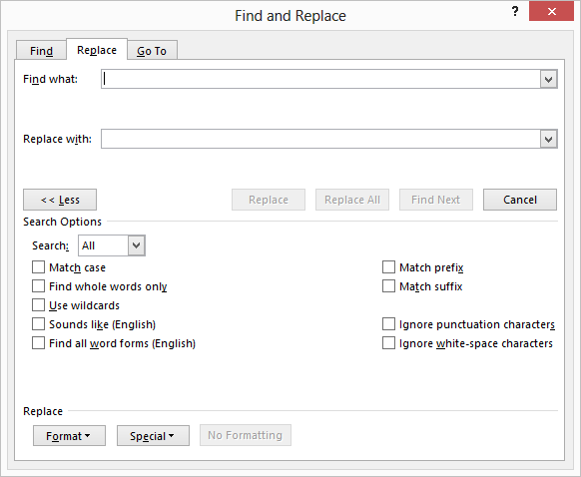
Figure 1. The Replace tab of the Find and Replace dialog box.
- Make sure that the Use Wildcards check box is selected.
- In the Find What box, type "(^2) " without the quotes. Note there's a space after the last parenthesis.
- With the cursor still in the Find box, click on the Format button, then choose Style. Word displays the Find Style dialog box.
- In the list of styles presented, choose the Footnote Text style and click on OK.
- In the Replace With box, type "\1^t" without the quotes.
- Press Replace All, then close the Find and Replace dialog box.
When done, all of the footnotes will have the requisite tab between the footnote reference number and the beginning of the footnote text. This works because you are using the ^2 wildcard in the search, which searches for footnote or endnote reference marks. The parentheses surrounding the ^2 causes that wildcard to be treated as a group. Essentially, the Find What box will look for all footnote or endnote reference marks followed by a space that are in paragraphs formatted with the Footnote Text style. The only place that this combination occurs is in the footnote itself. Endnotes are in the endnote style, and the main body of the document should not be in the Footnote Text style. In the Replace With box, the character \1 will replace the first expression that is between parentheses in the Find What box. In our case, that is the footnote reference number. The ^t will insert a tab.
Another approach is to use a macro that will place the requisite tab in the desired location in the footnotes. The following macro will do just that:
Sub TabFootnotes()
For s = 1 To ActiveDocument.Footnotes.Count
ActiveDocument.Footnotes(s).Range.Select
With Selection
.Collapse Direction:=wdCollapseStart
.MoveLeft Unit:=wdCharacter, Count:=1, Extend:=wdExtend
.TypeText Text:=vbTab
End With
Next
End Sub
This macro steps through each footnote, selects the footnote text, deletes the space at the beginning of the text, and then types a tab. In reality, the macro does not check to make sure that the character at the beginning of the text is a space; it could just as easily be a tab from a previous invocation of this macro. That is OK, however, as replacing an existing tab with a new tab will work just fine and still give the desired results.
There is a final approach that is appropriate if you want to always make sure there is a tab after the footnote reference number. This approach involves replacing Word's built-in command for inserting footnotes:
Sub InsertFootnote()
If Selection.StoryType <> wdFootnotesStory Then
Dim dlg As Dialog
Set dlg = Dialogs(wdDialogInsertFootnote)
If dlg.Display = -1 Then
dlg.Execute
Selection.TypeBackspace
Selection.TypeText vbTab
End If
End If
End Sub
This macro first checks to make sure that you aren't trying to insert a footnote while in the footnote section of the document. Then it displays the regular Footnote and Endnote dialog box. When you click on OK in the dialog box, the macro inserts a tab and waits for you to type the text of your footnote. This macro will also insert tab characters between endnote references and endnote text.

