Bullet Points in Microsoft Office

- Go to Wingdings font

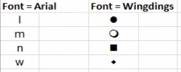

IN Excel

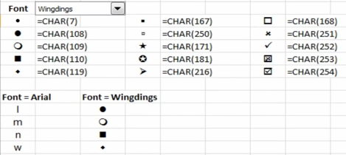

Press Alt key and number pad numbers for bullets
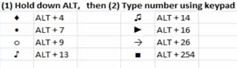

- Or insert Symbols – Wingdings font is great for items to choose.

