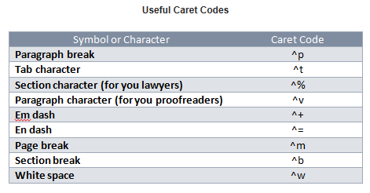

Reference

Codes You Can Use in the
“Find What” and “Replace With” Boxes
Character | Find  What | Replace With
Annotation Mark (comment) | ^a
Any character | ^?
Any digit | ^#
Any letter | ^$
Caret character | ^^ | ^^
Clipboard contents |  | ^c
Column break | ^n | ^n
Contents of the Find What box |  | ^&
Em dash | ^+ | ^+
En dash | ^= | ^=
Endnote mark | ^e
Field | ^d
Footnote mark | ^f
Graphic | ^g
Line break | ^l | ^l
Manual page break | ^m | ^m
Nonbreaking hyphen | ^~ | ^~
Nonbreaking space | ^s | ^s
Optional hyphen | ^- | ^-
Paragraph mark | ^p | ^p
Section break | ^b
Tab character | ^t | ^t
White space | ^w

