Change Label size
There are a couple of to change label size without the requirement of recreating the entire document. It is important, though, to remember that a label document is nothing but a large table that is formatted to match the dimensions of your labels. Understanding this, you could easily examine the table settings used in creating Avery 5163 labels and then change the table settings in your old document to match them. Because you change the table settings to match what is required for the new labels, you should be able to print on them with no problems.
Another idea is to create a new document consisting of empty Avery 5163 labels and then copy the data from the old Avery 5162 document to the new document. As long as you don't copy the table structure—just the data—you should have no problem.
If your labels are all the same, then the easiest method of converting to the desired label format is simply to use much of the same process you used to create the labels in the first place. Follow these steps:
- Open the existing document, the one that contains your labels in the Avery 5162 format.
- Press Ctrl+A to select the entire document.
- 3 Display the Mailings tab.
- Click the Labels tool in the Create group. Word displays the Labels tab of the Envelopes and Labels dialog box. (See Figure 1.)
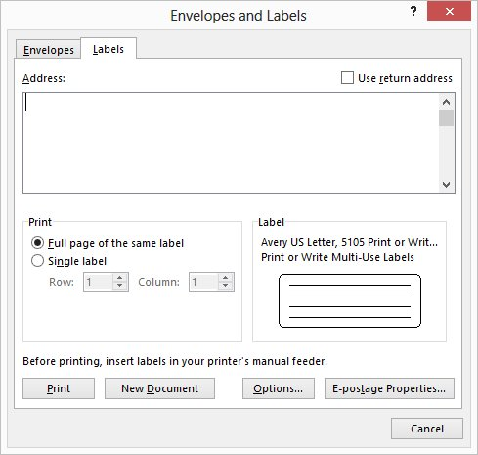
Figure 1. The Labels tab of the Envelopes and Labels dialog box.
- Click Options. Word displays the Label Options dialog box. (See Figure 2.)
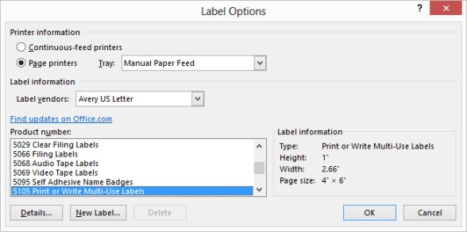
Figure 2. The Label Options dialog box.
- Using the Label Vendors drop-down list, choose Avery US Letter.
- In the Product Number list, choose 5163.
- Click OK. Word closes the Label Options dialog box.
- Make sure the Full Page of Same Label radio button is selected.
- Click New Document. Word creates a new document using the label format you specified in steps 6 and 7.
At this point you should have two documents—one that is your original (Avery 5162 format) and one that is your new document (Avery 5163 format). The new document contains a full set of labels based on the first label in your original document.

