Changing Column Width
Word allows you to quickly adjust the width of individual columns in your document, as well as the space between columns. You can change the width of columns in your document in the following manner:
- Position the insertion pointer somewhere within the text that is already formatted for columns.
- Display the Page Layout tab of the ribbon.
- Click the Columns tool in the Page Setup group. Word displays a drop-down list of options.
- Choose More Columns. Word displays the Columns dialog box. (See Figure 1.)
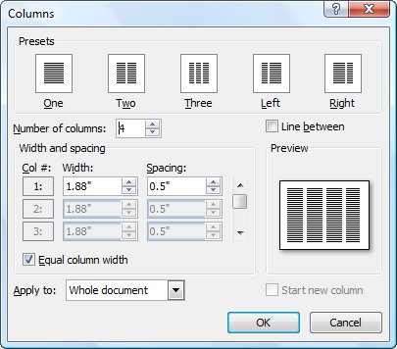
Figure 1. The Columns dialog box.
- Clear the Equal Column Width check box if you don't want your columns to be an equal width. (The Equal Column Width check box is only accessible if you set the Number of Columns control to some value other than 1.)
- In the Width and Spacing area of the dialog box, adjust the width and spacing (the space between columns) for each column to reflect your desired page appearance. As you adjust one number, other columns and widths may be adjusted automatically. All these numbers are inter-related.
- Click on OK.

