Changing the Default Font for Envelopes
Word includes an Envelopes feature that makes it pretty easy to create your own professional-looking envelopes. The feature makes certain assumptions about how different parts of the envelope should be printed. This includes the font that Word uses to print the envelope's information.
When creating an envelope, Word depends on predefined styles. The style used for the main address on the envelope is, appropriately enough, Envelope Address. Likewise, the style used for the return address is named Envelope Return. When you instruct Word to create the envelope, these styles are grabbed and used for formatting the addresses on the envelope.
If you want to change the font used by Word in creating envelopes, you need to change the style used for this purpose by Word. To do this, follow these steps:
- Create a new, blank document. Unless you specify a different template, Word creates a new document based on either the Normal.dotx or Normal.dotm template, depending on your system. (If you want to fix this problem in other templates, you should open the template directly or create a blank document based on that template.)
- Display the Home tab of the ribbon.
- Click the small icon at the bottom-right of the Styles group. Word displays the Styles pane at the right side of the desktop.
- Click Options at the bottom of the Styles pane. Word displays the Style Pane Options dialog box. (See Figure 1.)
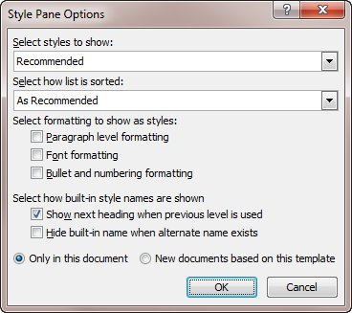
Figure 1. The Style Pane Options dialog box.
- Using the Select Styles to Show drop-down list, choose All Styles.
- Click OK to close the Style Pane Options dialog box.
- In the Styles pane, scroll through the list of styles until you see the Envelope Address style.
- Hover the mouse pointer over the Envelope Address style name. Notice that a downward-pointing arrow appears at the right side of the style name.
- Click on the downward-pointing arrow and choose the Modify option from the resulting menu. Word displays the Modify Style dialog box. (See Figure 2.)
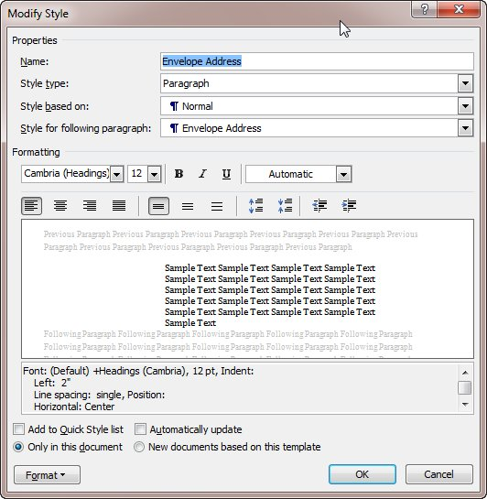
Figure 2. The Modify Style dialog box.
- Click on the Format button, then choose the Font option. Word displays the Font dialog box. (See Figure 3.)
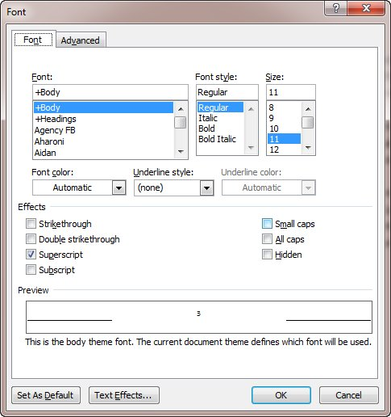
Figure 3. The Font dialog box.
- Change the font information, as desired.
- Click on OK to close the Font dialog box.
- Make sure the New Documents Based On this Template radio button is selected.
- Click on OK.
- Close the Styles pane, if desired.
When done, you should repeat these steps if you want to change the font used for the return address. The only difference, of course, is that in steps 7 and 8 you should select the Envelope Return style.
When you save your document or close Word, you are asked if you want to save your changes to the template. Make sure you do this. Your envelopes, when created in a document that uses this template, should now use the font you specified.

