Controlling Widows and Orphans
In typographical terminology, widows and orphans are closely related (no pun intended). These terms refer to one (and sometimes two) lines of a paragraph left by itself on a page. A widow is the last line of a paragraph left by itself at the top of a page; an orphan is the first line of a paragraph left by itself at the bottom of a page. You will want to avoid both widows and orphans in your documents, as they break up the flow of the text and tend to distract the reader.
Word allows you to automatically control single-line widows and orphans in your documents. To control widows and orphans in your documents, follow these steps:
- Put the insertion point in the paragraph that has either the widow or orphan text.
- Display the Paragraph dialog box. (Display the Home tab of the ribbon and click the small icon at the bottom-right of the Paragraph group.)
- Display the Line and Page Breaks tab. (See Figure 1.)
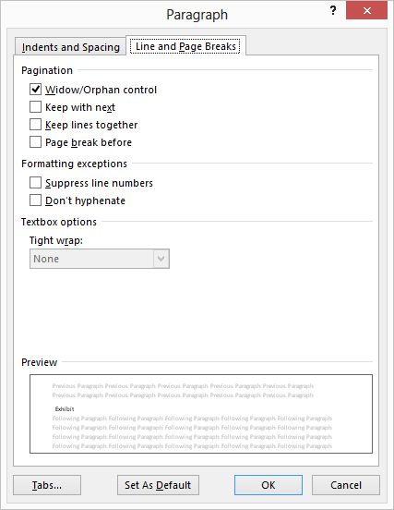
Figure 1. The Line and Page Breaks tab of the Paragraph dialog box.
- Make sure the Widow/Orphan Control check box is selected.
- Click on OK.
There are two ways of applying this information without the need to "MANUALLY search" anything.
First, you could select the entire document (Ctrl+A) and change the setting.
Second, a better way is to define the setting as part of the styles you use in your document.
Either way, there is nothing manual about it -- the setting is then automatically applied throughout the document, even if you change where page breaks occur by adding or removing paragraphs.

