Copy Fill Color in a Table
There is a way to copy the fill color from one row to another.
There are a few ways that you can approach this issue. One is to simply use the tools that are available in Word. Follow these steps:
- Select the row that is already filled with the desired color.
- Display the Design tab of the ribbon.
- Click the down-arrow to the right of the Shading tool, in the Table Styles group. (The tool looks like a spilling bucket of paint.) Word displays a palette of colors.
- Click on More Colors. Word displays the Colors dialog box. (See Figure 1.) The color of the selected row should already show in the dialog box.
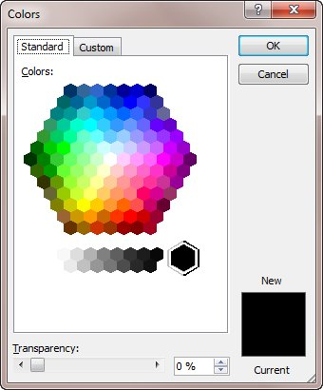
Figure 1. The Colors dialog box.
- Click OK. (Note that you made no changes in the dialog box; you just clicked OK.)
- Select the other rows in the table whose background color you want to change.
- Click on the Shading tool on the Design tab of the ribbon. Your desired color is applied to the selected rows.
After you apply the desired color, if you want to apply it elsewhere (perhaps in another table or in some cells you missed), all you need to do is select the cells and press F4. The shading is repeated on the selected cells.
If you need to do this quite a bit with a number of tables or in a number of documents, you may want to consider using a macro to do the shading. A handy little macro is the one below:
Sub ShadeTable()
Dim backColor As Long
Dim foreColor As Long

If Selection.Information(wdWithInTable) Then
With Selection.Tables(1)
backColor = .Cell(1, 1).Shading.BackgroundPatternColor
foreColor = .Cell(1, 1).Shading.ForegroundPatternColor
.Shading.BackgroundPatternColor = backColor
.Shading.ForegroundPatternColor = foreColor
End With
Else
MsgBox "Put the insertion point in a table"
End If
End Sub
The macro shades an entire table based on the shading used in the first cell of the first row of the table. All you need to do is make sure you place the insertion point somewhere within the table before running it. This macro is a variation of the macro mentioned at the following website:
http://www.wordbanter.com/showthread.php?t=84194

here is the macro form that site.

Sub TableBackColor()
' set the background color of
' an entire table the same as
' that of the first cell
If Not Selection.Information(wdWithInTable) Then
MsgBox "Put the cursor in a table"
Exit Sub
End If
Dim backColor As Long
Dim foreColor As Long
With Selection.Tables(1)
backColor = .Cell(1, 1).Shading.BackgroundPatternColor
foreColor = .Cell(1, 1).Shading.ForegroundPatternColor
.Shading.BackgroundPatternColor = backColor
.Shading.ForegroundPatternColor = foreColor
End With
End Sub

