Counting Values in Table Cells
- Select the column that contains the single characters. (If the first row in the column contains some header text that contains F, P, or B, then don't include the first cell in your selection.)
- Press Ctrl+H to display the Replace tab of the Find and Replace dialog box. (See Figure 1.)
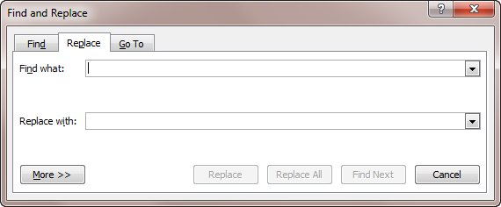
Figure 1. The Replace tab of the Find and Replace dialog box.
- In the Find What box, enter the letter you want to search for (F, P, or B).
- In the Replace With box, enter "^&" (without the quote marks).
- Click Replace All.
The result is that the character is replaced with itself, and Word lets you know how many replacements were made. (If Word asks you if you want to make the replacements in the rest of the document, turn down the kind offer.) You can repeat the steps for each of the other characters in the column, and you will have your desired counts.
Or:
Select the column. Use CTRL+F. we get the search and navigation pane. Enter the letter to be searched. Word gives the number of times, the letter appears in the column.

