Creating a Four Fold Greeting Card in Word

Follow the following steps to create a greeting card on one sheet of paper that simple needs to be folded in four and it is ready to send.

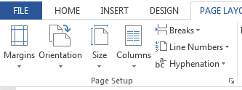
- Open a new document
- Rotate paper
  - Page layout
  - Orientation
  - Landscape
- Set margins
  - Page Layout
  - Margins
    - Top .5
    - Left .5
    - Right .5

- Accept settings

- On the ruler slide the bottom margin clear to the bottom.

- Click insert

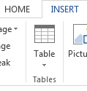
- Click Table
  - Select 3 x 3

- On the tables tools tab click Layout

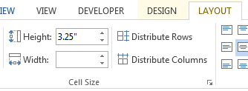
- Make the top row
  - first cell
    - Height 3.25
    - Width 4.5
  - Second cell
    - Width 1
  - Third cell
    - Width 4.5
- Middle Row
  - Height 1
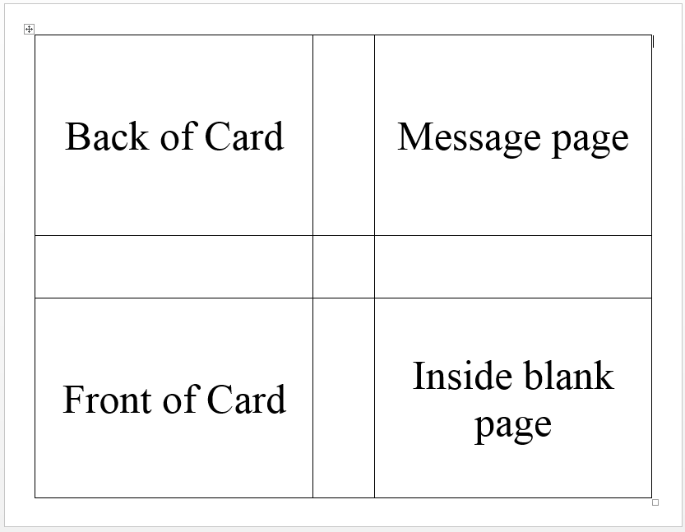
- Bottom Row
  - Height 3.25
- Select all cell
- Click center

- Your card should look like this picture (without the words). The words show you which part of the card will be displayed at what part of the card. Now we need to add the items to the card. They text will have to be rotated. The borders will have to be removed. It may be easiest to enter the text before you rotate and remove borders. If you prefer to rotate and remove borders first go to steps 18 to 22 below and then enter the text and images (steps 15 to 17). Otherwise enter the text and pictures and then proceed to the rotation and border removal.

- Enter the text for the Front of the Card and the message in the appropriate cells.

- Add a picture with the insert tab if you wish

- Rotate and size the picture as needed to fit in the selected area of the card.

- Select the first column and on the Layout tab, Click Text Direction until the top of the text is toward the middle of the page.
- Select the third column and on the Layout Tab, click Text Direction until the top of the text is toward the middle of the page.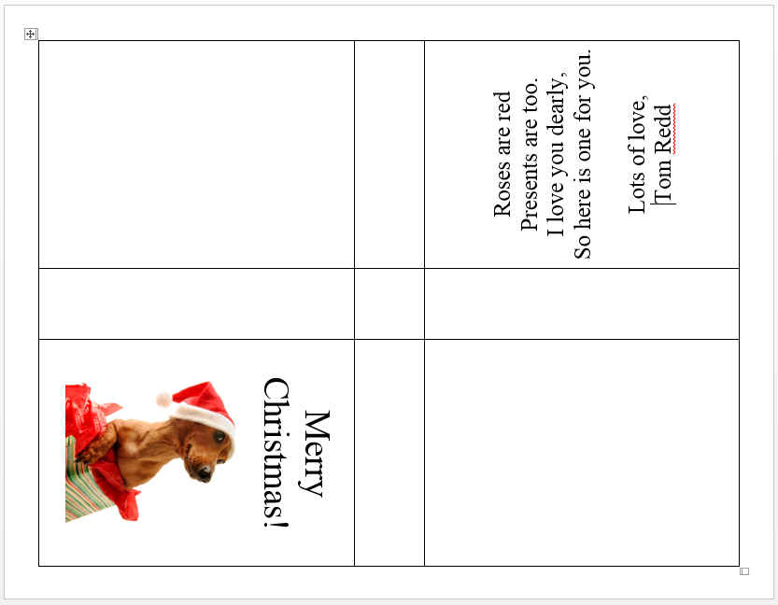
- Click the Design tab
- Click the Borders Button
- Click no Borders
- Your card is ready to print and fold with the writing toward the outside and the front of the card toward the front. (You may receive an error message about margins when you print. Ignore it and print anyway.)

