Creating a Full-Page Border
Not only can you add borders to your paragraphs, but you can place one on an entire page. You do this by following these steps:
- If you are not going to apply the border to all the pages in your document, position the insertion point in the section that will use the borders.
- Make sure the Design tab of the ribbon is displayed.
- Click the Page Borders tool in the Page Background group. Word displays the Page Border tab of the Borders and Shading dialog box. (See Figure 1.)
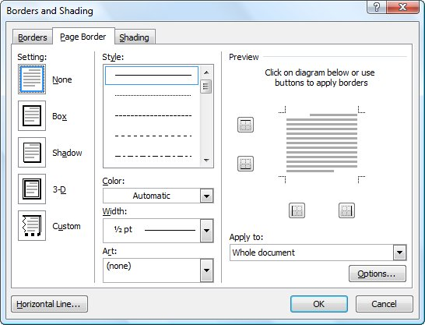
Figure 1. The Page Border tab of the Borders and Shading dialog box.
- Use the controls in the dialog box to specify how you want your border to appear. These controls are very similar to those used by Word to set up paragraph borders.
- Unlike adding borders to paragraphs, you can use the Art drop-down list to select an artistic treatment to use for your border.
- Use the Apply To drop-down list to select what parts of your document should use the border.
- Click on OK.

