Displaying Nonprinting Characters
by Allen Wyatt (last updated September 28, 2013)
There are several different characters, such as a space and tab, which Word does not normally display on the screen. In addition, there are several special characters that Word uses for housekeeping purposes. For instance, Word uses special characters to indicate the end of a line or the end of a paragraph. You can display these special characters, which Word refers to as nonprinting characters, by following these steps:
- Display the Word Options dialog box. (In Word 2007 click the Office button and then click Word Options. In Word 2010 and Word 2013 display the File tab of the ribbon and then click Options.)
- Click Display at the left side of the dialog box. (See Figure 1.)
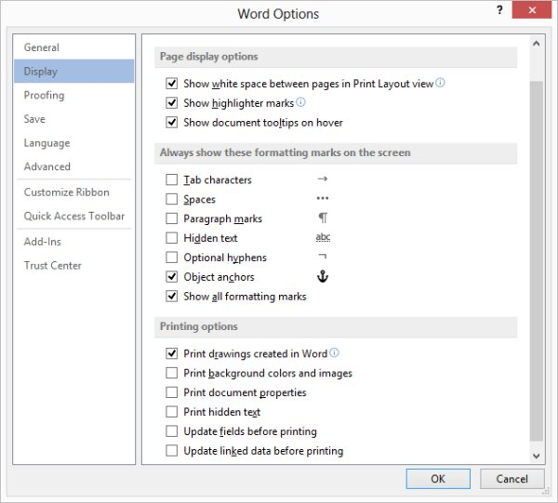
Figure 1. The display options in the Word Options dialog box.
- In the Always Show These Formatting Marks On the Screen section, select the characters you want Word to display.
- Click on OK.
Why would you want to display these characters? Quite simply because it is much easier to understand spacing when the characters are displayed. You can quickly tell, for instance, when you have inserted two spaces between words or added an extra carriage return. This allows you to more accurately control the look of your document and what it contains.
There is also a quick way you can turn nonprinting characters on and off using the ribbon. Display the Home tab of the ribbon and look for a tool in the Paragraph group that looks like a backwards P. (Technically this character is called a pilcrow.) This tool is known as the Show/Hide tool. Clicking it (or pressing Ctrl+*) toggles the condition of the Show All Formatting Marks checkbox in the dialog box shown earlier. Thus, it can quickly turn on and off the nonprinting character display.
There is one interesting "gottcha" to this, however. In the dialog box you can select to individually display or hide specific nonprinting characters. If you select the checkboxes for all these individual characters, using the Show/Hide tool still only toggles the Show All Formatting Marks checkbox—the individual settings for specific characters are not affected at all.

