Double Space Document Quickly
If you are writing and you need a printed copy of your manuscript double-spaced, you probably will want to keep your manuscript single-spaced so you can see more of it on the screen at a time. When you are ready to print, there is a quick way to double-space your document:
- Save your document.
- Press Ctrl+A or choose Select All from the Edit menu.
- Display the Home tab of the ribbon.
- Click the small icon at the bottom-right corner of the Paragraph group. Word displays the Paragraph dialog box. (See Figure 1.) Notice that, contrary to the figure shown here, none of the fields are filled in. This is because you have selected the entire document, and no single paragraph setting applies to the entire document.
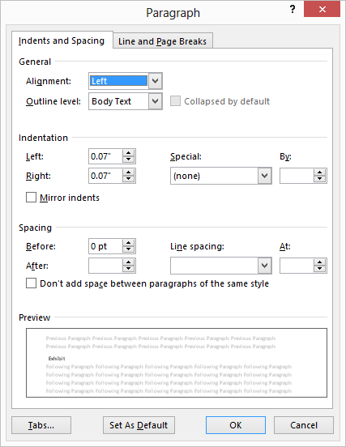
Figure 1. The Paragraph dialog box.
- Choose Double in the Line Spacing box.
- Click on OK.
- Print your document.
- Close your document without saving.
This last step is important. If you save your document before exiting, then the double spacing will be permanently saved with the document, as well.

An Even Faster method follows:
[CTRL][A] selects all, [CTRL][2] (using the numeric keys at the top of the keyboard, not the numberpad) double-spaces.
Other useful combinations:
[CTRL][1] single spaces
[CTRL][2] double space
[CTRL][5] produces space-and-a-half
[CTRL][0] gives extra space between paragraphs.

