This is Page 2 | 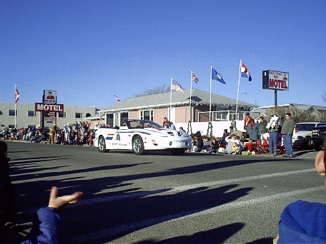  This is page 1  Front of the book
This is Page 3 | This is page 8  Back of the book
This is Page 4 | This is page 7
This is Page 5 | This is page 6

