Finding Where Templates Are Stored
It is unfortunate that Microsoft does not make it easier to modify templates. The first step in modifying templates is to load one, and that means you need to know where they are stored on disk. Regrettably, the average user hasn't a clue where they are stored on disk. The problem is that even Word Help cannot say exactly where the templates folder is on any particular computer.
If you want to know where your templates are stored, follow these steps:
- Display the Word Options dialog box. (In Word 2007 click the Office button and then click Word Options. In Word 2010 display the File tab of the ribbon and then click Options.)
- Click Advanced at the left side of the dialog box.
- Scroll to the bottom of the available options and click the File Locations button. Word displays the File Locations dialog box. (See Figure 1.)
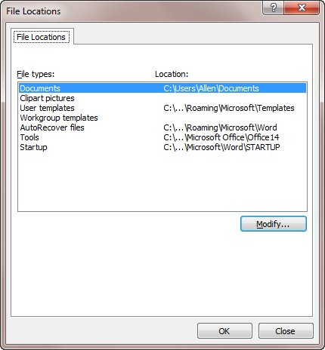
Figure 1. The File Locations dialog box.
- In the File Types list, choose User Templates. If the path for the templates is short enough, you may be able to see it in the dialog box right now. If so, you can skip steps 5 and 6.
- Click the Modify button (even though you won't be modifying anything.). Word displays the Modify Location dialog box.
- The Look In drop-down list, at the top of the dialog box, contains the current path name used for templates.

