Hidden Text to Non-Hidden Text
If you have a document full of hidden text, you may wonder how to convert all that text so it is non-hidden. The answer is to use Word's Find and Replace feature. Follow these steps:
- Press Ctrl+Home to jump to the beginning of the document. (This isn't technically necessary, but makes finding and replacing just a bit easier.)
- Press Ctrl+H. Word displays the Replace tab of the Find and Replace dialog box.
- Click the More button, if it is available. (See Figure 1.)
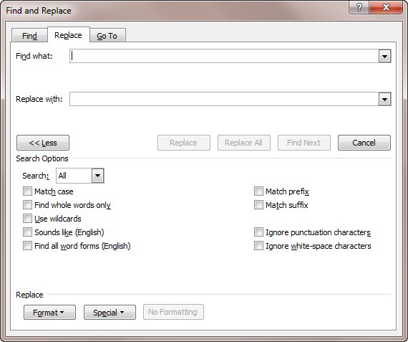
Figure 1. The Replace tab of the Find and Replace dialog box.
- Make sure there is nothing in the Find What box, and that the insertion point is in the box.
- If the No Formatting button is available, click it.
- Click the Format button and choose Font. Word displays the Find Font dialog box. (See Figure 2.)
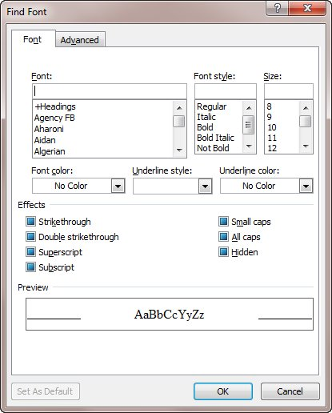
Figure 2. The Find Font dialog box.
- Click the Hidden check box. A check mark should appear in the check box. (If a check mark doesn't appear, keep clicking the check box until one does.)
- Click OK. The Find Font dialog box disappears, and the word "Hidden" appears beneath the Find What box.
- Make sure there is nothing in the Replace With box, and that the insertion point is in the box.
- If the No Formatting button is available, click it.
- Click the Format button and choose Font. Word displays the Replace Font dialog box.
- Click the Hidden check box twice. The check box should be empty. (If it is not empty, keep clicking the check box until it is.)
- Click OK. The Replace Font dialog box disappears, and the words "Not Hidden" appear beneath the Replace With box.
- Click Replace All.
This series of steps finds all the text in the document that has the Hidden attribute set. It then turns off the attribute, so that none of your text is hidden any more.

