insert the total number of pages in your document, follow these steps:
- Position the insertion point where you want the total number of pages to appear.
- Make sure the Insert tab of the ribbon is selected.
- In the Text group, click Quick Parts. You'll see a drop-down menu.
- Choose Field. Word displays the Field dialog box.
- In the Categories drop-down list, choose Document Information. (See Figure 1.)
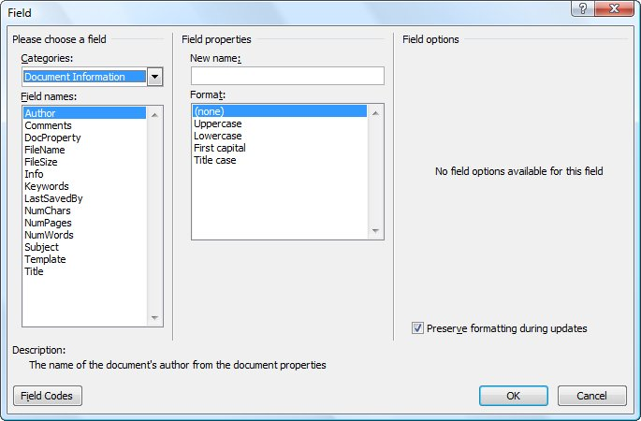
Figure 1. The Field dialog box.
- In the Field Names list choose NumPages.
- Click on OK to close the dialog box and insert your field.

