Inserting Custom Properties with Fields
by Allen Wyatt (last updated August 24, 2013)
Word maintains a number of different properties related to your documents, as a whole. You can see what these properties are by displaying the Properties dialog box. How you display that dialog box depends on the version of Word you are using:
- If you are using Word 2010 or Word 2013, click the File tab of the ribbon and make sure that Info is selected at the left side of the screen. Then click the Properties drop-down list (upper-right side of the screen) and choose Advanced Properties.
- If you are using Word 2007, click the Office button, click Prepare, then Properties. Word displays the Document Information Panel at the top of your document, just below the ribbon. Use the Document Properties drop-down list (top-left corner of the Document Information Panel) to choose Advanced Properties.
The Properties dialog box is full of information maintained by Word. You can even use the Custom tab in the dialog box to create your own custom properties for your documents.
Inserting the values of properties into a document is done using different fields. Pre-defined properties have their own corresponding fields. For instance, if you want to insert a document's creation date into your text, you do so using the CreateDate field.
What you may not know is how to insert in your document values assigned to custom properties—the properties you create. In order to do this, let's assume you have created a custom property named MyProp. To insert the value of this property in your document, follow these steps:
- Position the insertion point where you want to insert the value of the custom property.
- Make sure the Insert tab of the ribbon is displayed.
- Click the Quick Parts tool in the Text group. You'll see a list of options.
- Choose Field. Word displays the Field dialog box. (See Figure 1.)
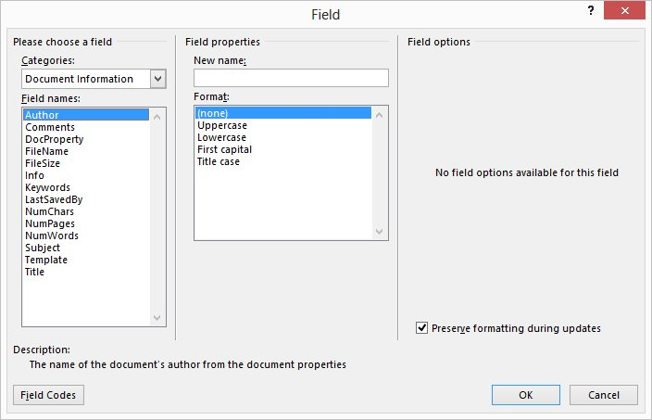
Figure 1. The Field dialog box.
- In the list of Categories, choose Document Information.
- In the list of Field Names, choose DocProperty.
- In the Property list, choose the custom property you created (MyProp).
- Click on OK. Word inserts the value of MyProp in your document.

