Keeping Tables on One Page
As you develop more complex Word documents, it is inevitable that you will add tables. Most tables are relatively short and can easily fit on a page. Because of this, it can be disconcerting to have a page break occur in the middle of a table. Here's an approach that has always worked for me:
- Select all the rows in the table.
- Display the Home tab of the ribbon.
- Click the small icon at the bottom-right of the Paragraph group. Word displays the Paragraph dialog box.
- Make sure the Line and Page Breaks tab is selected. (See Figure 1.)
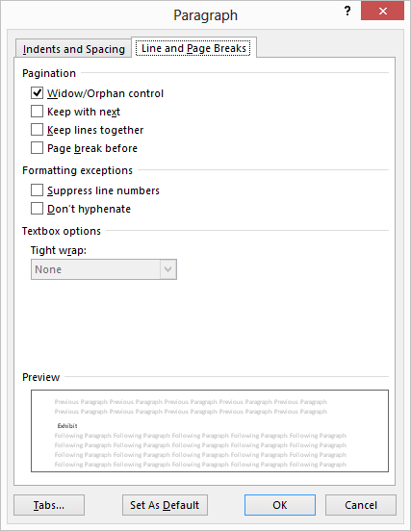
Figure 1. The Line and Page Breaks tab of the Paragraph dialog box.
- Make sure the Keep Lines Together check box is selected.
- Click on OK.
Now you need to repeat the same steps, with two minor variations. First, in step 1 select all the rows except the last one. Then, in step 5, make sure the Keep With Next check box is selected. This is necessary (performing this step with the last row not selected) so that the table stays together as a unit, rather than the table staying with the paragraph that follows it.

