Making Draft View the Default View
by Allen Wyatt (last updated September 13, 2014)
Word allows you to work with your document using several different "views." Each view has a specific purpose and allows you to examine the document differently. (The difference between Word's views is discussed fully in other WordTips.) The easiest way to switch between views is to use the small view icons on the status bar.
Normally Word displays your document in Print Layout view, in an attempt to approximate what your document will look like when you print it. You may, however, want to use a different view as your default. For instance, many people like to work on their documents in Draft view.
Word is supposed to remember which view you last used with a document. Set a view, save the document, and then the next time you open the document, it should be opened using that view. There are times, however, when it can seem like this isn't the case; like Word is "confused" as to which view it should use with a document.
This may be because you haven't set up Word to pay attention to the Draft view setting. As documented in the Microsoft Knowledge Base (article 919599) you can change this setting in this manner:
- Display the Word Options dialog box. (In Word 2007 click the Office button and then click Word Options. In Word 2010 and Word 2013 display the File tab of the ribbon and then click Options.)
- Click Advanced at the left side of the dialog box.
- Scroll down until you see the General settings in the dialog box. (See Figure 1.)
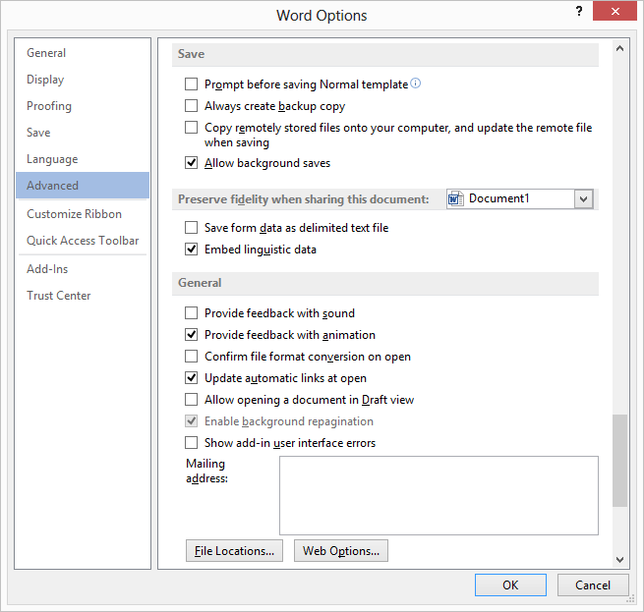
Figure 1. The advanced options of the Word Options dialog box.
- Make sure the Allow Opening a Document in Draft View option is set.
- Click OK.
Once done, switch to Draft view and save your document. When you reopen it, the view you want should be used. If you want the Draft view to be used in all future (new) documents, you'll want to make sure that you load the Normal template, change to Draft view, and then resave the template.
There is a big caveat here: Since Word "remembers" the view in which a document was last used (before it was last saved), if you have any documents that were not in Draft view before you saved them, then those documents will not be in Draft view when you next open them. Each of them will need to be opened individually, switched to Draft view, and then resaved. This applies, as well, to documents created by other people—Word will remember the view in which those documents were last saved and then use that view when the document is opened again.

