Positioning Line Numbers
by Allen Wyatt (last updated December 30, 2014)
In other issues of WordTips you learn how to add line numbers to your document. Word also allows you to modify how far line numbers are from the text in your document. To do this, follow these steps:
- Display the Page Layout tab of the ribbon.
- Click the Line Numbers tool (in the Page Setup group) and then choose Line Number Options. Word displays the Layout tab of the Page Setup dialog box.
- Click on the Line Numbers button. Word displays the Line Numbers dialog box. (See Figure 1.)
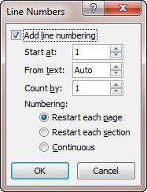
Figure 1. The Line Numbers dialog box.
- Adjust the measurement in the From Text box to indicate how far the line numbers appear from your text.
- Click on OK to close the Line Numbers dialog box.
- Click on OK to close the Page Setup dialog box.

