Searching for Breaks

- Press Ctrl+H and then click the Find tab. (See Figure 1.)
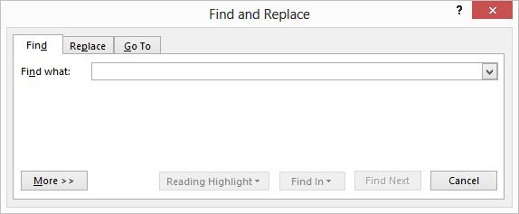
Figure 1. The Find tab of the Find and Replace dialog box.
- In the Find What box, enter the text for which you want to search. To search for a page break enter ^m. To search for a section break, enter ^b. To search for a column break, enter ^n. Note that it is important to use lowercase characters. You can also select these and other types of special characters by clicking on the Special button. (If you click the More button in the Find and Replace dialog box you'll see the Special button.)
- Set other searching parameters, as desired.
- Click on Find Next.

