Searching for Footnote and Endnote Marks

If you don't know where a footnote or endnote reference is located in your document, you can use Word's powerful searching capabilities to find automatic footnote references. To search for a footnote, follow these steps if you are using Word 2007:
- Press Ctrl+F to display the Find tab of the Find and Replace dialog box. (See Figure 1.)
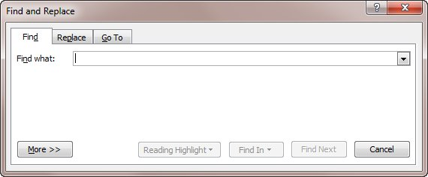
Figure 1. The Find tab of the Find and Replace dialog box.
- In the Find What box, enter the text for which you want to search. To search for a footnote mark, enter ^f. To search for an endnote mark, instead enter ^e.
- Set other searching parameters, as desired.
- Click on Find Next
  - If you want to find all the marks at once, do the following instead of clicking find:
    - Click Find In
    - Click Main Document
If you want them all highlighted for reading click the Reading highlight button and click highlight All. You can remove highlights by click remove highlights.
Once you have the Find and Replace dialog box visible (down triangle at the right of the search box in the Navigation pane and select Advanced Find...) you can select More>> then Special to search for Paragraph marks, Section breaks, non-breaking hyphens and many more 'special' characters.

You could also use ^p for 'Paragraph Mark', ^l (Ctrl+small L) for 'Line Break Mark', ^s for 'Non-Breaking Space' widely.

