Seeing Where Bookmarks Are
The bookmarking feature in Word has many uses. As you start to learn those uses and create more and more bookmarks, it can be difficult to remember where bookmarks are in your documents. While you can easily jump from one bookmark to another, sometimes it is easier to just see where your bookmarks are at a glance. Word makes this easy by following these steps:
- Display the Word Options dialog box. (In Word 2007 click the Office button and then click Word Options. In Word 2010 and Word 2013 display the File tab of the ribbon and then click Options.)
- Click Advanced at the left side of the dialog box.
- Scroll down until you see the Show Document Content section. (See Figure 1.)
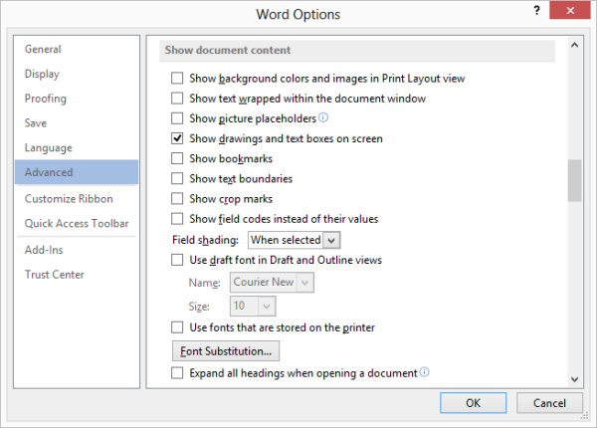
Figure 1. The advanced options of the Word Options dialog box.
- Make sure the Show Bookmarks check box is selected.
- Click on OK.
Now you will see small, gray brackets around words or phrases that are bookmarked. If you see a small gray I-beam in your text, it means there is a bookmark set at that single location, rather than a word or phrase specified. These marks appear only on the screen; they do not print out with the document. If you reverse the above steps, the bookmark indicators are removed from the screen.
Note that this technique allows you to see the bookmarks you explicitly add to a document. Word uses bookmarks internally for some purposes; those types of bookmarks are not displayed by turning on the Show Bookmarks setting.

