Single Click to Follow Hyperlinks
It is not necessary to hold the control key and click when you want to follow a hyperlink in a document. Instead you can set Word to go to hyperlinks by just a single clicking on the highlighted link in the document. This is simpler and faster.
- Display the Word Options dialog box.
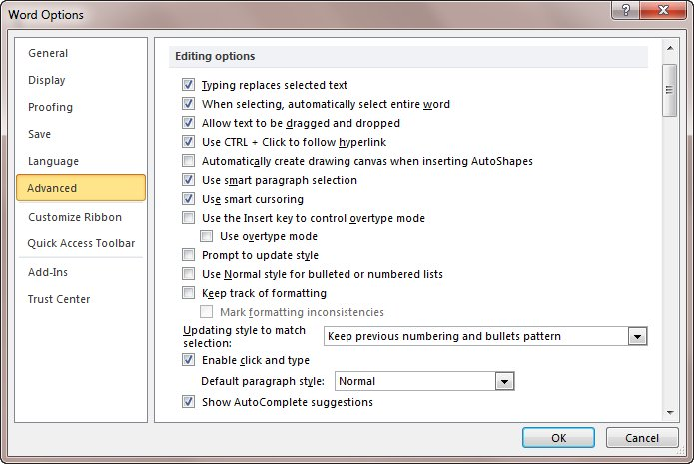
- At the left side of the dialog box, click Advanced. (See Figure 1.)
Figure 1. The Advanced options of the Word Options dialog box.
- In the Editing section of the dialog box, clear the Use Ctrl+Click to Follow Hyperlink check box.
- Click on OK.
There is no need to Ctrl+Click to go to a hyperlink now. All it takes is a single click on the hyperlink to make the jump.

