Sort a list alphabetically

You can sort a one-level bulleted or numbered list so that the text is in alphabetical order. You can sort in ascending order (A to Z) or in descending order (Z to A).
- Select the text in a bulleted or numbered list.
- On the Home tab, in the Paragraph group, click Sort.
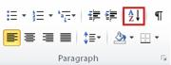
- In the Sort Text dialog box, under Sort by, click Paragraphs and Text, and then click either Ascending or Descending.

