Using a Single-Column Heading in a Multi-Column Layout
There may be many times when your document layout calls for using a single-column section in the middle of a multi-column page layout. For instance, if you are creating a newsletter, you may want three columns in the newsletter, but a headline that spreads across all the columns. To do this, follow these steps:
- Format your page so that it uses three columns.
- Type your newsletter article. It should spread across the three columns as you would expect.
- At the beginning of the article, type the text that you want to appear as the headline or banner. (Make sure you press Enter at the end of the headline or banner.)
- Select the paragraph containing the headline or banner.
- Display the Page Layout tab of the ribbon.
- Click the Columns tool and then click More Columns. Word displays the Columns dialog box. (See Figure 1.)
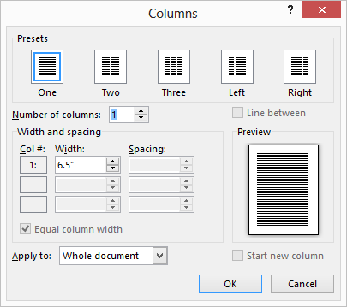
Figure 1. The Columns dialog box.
- Choose One from the Preset area at the top of the dialog box.
- Using the Apply To drop-down list, choose Selected Text.
- Click on OK.
- Format your headline paragraph the way you want it to appear.

