Using Outline Numbering in a Table
It is possible to use outline numbering in a table. The problem here is how you are choosing to advance between bullet tiers. The Tab key, in a table, is always used to move from one cell to another. To change indent levels—which gives you the next level of bullets or numbering—you need to use the Promote tool on the Outlining tab of the ribbon and, conversely, the Demote tool to return to a higher level. To find the Outline view, click View. Now click Outline in the Views section. This will change the ribbon so that there is a box that shows the Promote and Demote buttons.
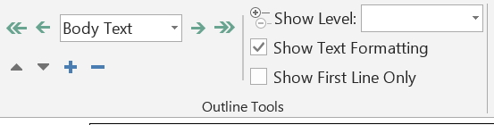
If, for some reason, you want to actually add a tab character in the text appearing in a cell, you need to press Ctrl+Tab.

