Vertical Alignment of an Inline Graphic

Robert notes that when he places an inline graphic in his document that is taller than a single line of text, the text defaults to being aligned with the bottom of the graphic. He wonders if it is possible to change that so the text is either center- or top-aligned with the graphic.
The effect that Robert is noticing is the default behavior for inline graphics, although the cause he cites is backwards—it is actually the graphic that defaults to bottom alignment with the text, not the text with the graphic. So the solution involves adjusting the vertical positioning of the graphic.
Word treats inline graphics as a single character. You can change the vertical alignment of an inline graphic by treating it as you would any other single character whose vertical position you wanted to adjust. Follow these steps:
- Select the inline graphic by clicking on it once.
- Press Ctrl+D. Word displays the Font dialog box.
- Make sure the Character Spacing tab is displayed. (See Figure 1.)
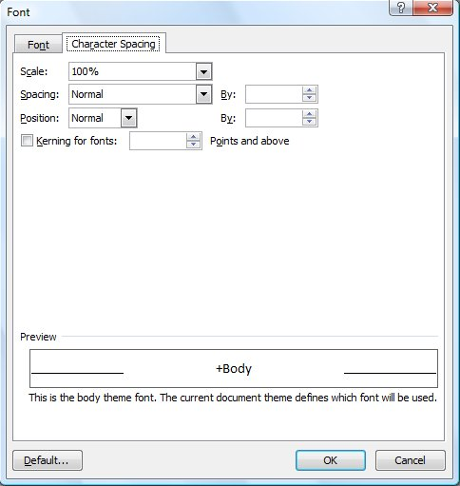
Figure 1. The Character Spacing tab of the Font dialog box.
- Using the Position drop-down list, choose Lowered.
- Enter a value in the By box, to the right of the Position control, that represents the number of points by which you want to lower the graphic.
- Click OK.
You may need to play with the value entered in the By box (step 5) to get just the look you want. The value you use will depend on the size of the graphic whose position you are adjusting and the characteristics of the font used in the paragraph.
If Word won't display the Font dialog box (step 2), then there are two possible reasons. First, your graphic may not really be inline. In order to follow the rest of the steps, you'll need to convert it to an inline graphic, as described in other WordTips. The other possible cause is that some graphics cannot, for whatever reason, be positioned as described here. If that is the case, you'll need to change to one of the non-inline graphics options, set the wrapping, and adjust the vertical position manually. If you need to do this, you may find it easier to insert the graphic into a text box before doing your positioning.

Once you have lowered one image as described, you can just click and ctrl-Y (redo) the next image (and so on...), which is a little faster than setting the position for each image. However it is still not an acceptable solution for hundreds of images.

