Vertical Lines in Word
by Allen Wyatt (last updated December 27, 2014)
For some documents you may have a need to insert vertical lines. There are actually four or five ways you can do this in Word. The actual method you choose depends on your document needs and which appeals to you the most. The first method involves drawing a line:
- Display the Insert tab of the ribbon.
- Click the Shapes tool and then click one of the line shapes from the Line group. The mouse pointer changes to a crosshair that looks like a large plus sign.
- Click at one end of where you want your line, but don't release the mouse button.
- Drag the mouse to where you want the other end of the line positioned.
- Release the mouse button.
The second method involves using bar tab stops. You can see how these appear by following these steps:
- Select the paragraph or paragraphs that you want to contain vertical bars.
- Display the Home tab of the ribbon.
- Click the small icon at the lower-right of the Paragraph group. Word displays the Paragraph dialog box.
- Click the Tabs button, at the lower-left of the dialog box. Word displays the Tabs dialog box. (See Figure 1.)
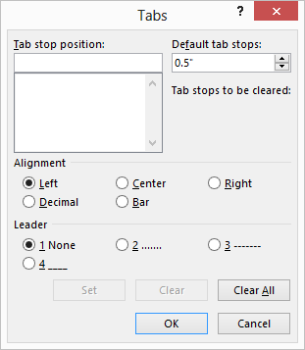
Figure 1. The Tabs dialog box.
- In the Tab Stop Position box enter a horizontal measurement that indicates where you want the bar to appear. Thus, if you want it 2 inches from the left margin, you would enter 2 in the box.
- Click on the Bar radio button.
- Click on Set.
- Repeat steps 5 through 7 to set other bar positions.
- Click on OK when you are done.
Another method that works well if you want the line to appear beside a paragraph is to use borders:
- Place the insertion point within a paragraph of text or, if preferred, select the entire paragraph.
- Display the Home tab of the ribbon.
- Click the down-arrow next to the Borders tool, in the Paragraph group. Word displays a drop-down list of options.
- Choose the Left Border or Right Border option, as desired. Word adds the border to either the left or right side of the paragraph, as appropriate.
If you have multiple columns in your document and you want vertical lines between the columns, you can follow these steps:
- Select the text that you want in columns. (If you don't do this step, then your entire section or document will be formatted into columns.)
- Display the Page Layout tab of the ribbon.
- Click the Columns tool in the Page Setup group and then click More Columns. Word displays the Columns dialog box. (See Figure 2.)
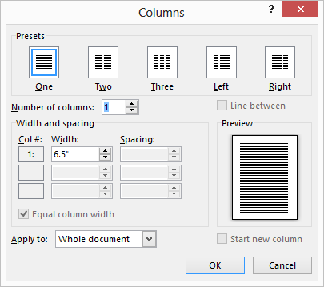
Figure 2. The Columns dialog box.
- Specify the number of columns into which you want the text formatted.
- Make sure the Line Between check box is selected.
- Click on OK.
The final way to create vertical lines is to use tables. While this may seem a bit convoluted, it will work great for small sections of text. To use this method, follow these general steps:
- Create a table that has a single row but as many columns as you want your text divided into.
- Select the table.
- Make sure the Design tab of the ribbon is displayed.
- Click the Borders tool (in the Table Styles group) and then choose No Border.
- Again click the Borders tool and then choose Inside Vertical Border.
- Enter your text in each cell of the table.

