Where Do You Want Your Endnotes?
Long-time users of Word know that you can place endnotes in a document and you can specify for them to appear either at the end of a section or at the end of the document as a whole. What you may not know is that you can choose to suppress endnotes for specific sections of your document.
What does this mean for you? Let's say that you have five sections in your document. The first four are "chapters," and the last one is an index. You may think that you are limited to placing your endnotes at the end of each chapter or after the index. Not so; you can specify that you want the endnotes to appear at the end of the fourth section, just before the index section. Just follow these steps:
- Create your document as you normally would.
- Place your endnotes as you normally would, making sure they are specified to appear at the end of the section. You should also make sure that the endnote numbering is set as Continuous.
- Position your insertion point in the first section of the document.
- Display the Page Layout tab of the ribbon.
- Click the small icon at the bottom-right of the Page Setup group. Word displays the Page Setup dialog box.
- Make sure the Layout tab is selected. (See Figure 1.)
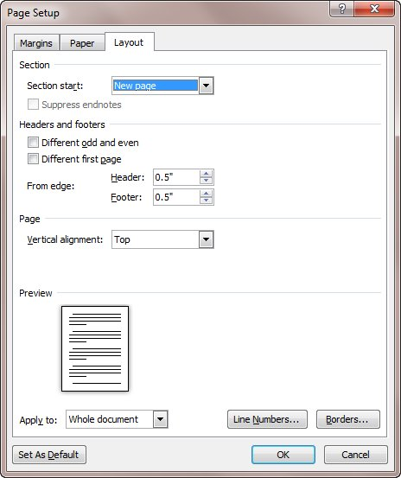
Figure 1. The Layout tab of the Page Setup dialog box.
- Choose the Suppress Endnotes checkbox.
- Click on OK.
- Repeat steps 4 through 8 for sections 2 and 3 in your document.
That's it. What you did was to suppress endnotes in sections 1, 2, and 3. This pushes them to the end of section 4, which is your last chapter—exactly where you wanted them before your index in section 5.

