Zooming with the Keyboard
For most purposes, Word allows you to issue commands and perform functions by using either the mouse or the keyboard. Unfortunately, Word does not provide "equal access" for all commands. For instance, it is relatively easy to zoom in or out using the mouse, but there is no easy way to do it using the keyboard.
Apparently, Microsoft feels that you can zoom simply by using whatever ribbon tools are necessary and then typing whatever percentage you desire. The steps to do this would be as follows:
- Press Alt. This activates the ribbon keystroke capabilities.
- Press W. This displays the View tab of the ribbon.
- Press Q. Word displays the Zoom dialog box. (See Figure 1.)
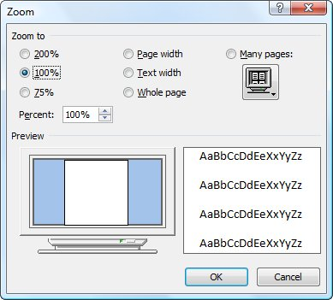
Figure 1. The Zoom dialog box.
- Press Alt+E. This moves the cursor to the Percent box.
- Type a new zoom percentage.
- Press Enter.
While this provides quite a bit of flexibility, it does not allow you to easily zoom in or out. If you want this ability in Word, the only way to get it is to create a macro and then assign the macro to a keyboard combination. For instance, the following macro will zoom into (enlarge) a document by 10%.
Sub MyZoomIn()
Dim ZP As Integer
ZP = Int(ActiveWindow.ActivePane.View.Zoom.Percentage * 1.1)
If ZP > 200 Then ZP = 200
ActiveWindow.ActivePane.View.Zoom.Percentage = ZP
End Sub
Notice that the macro only allows you to zoom in up to 200%. This is because Word allows you to only zoom that high, and any higher would generate an error. A slight variation on the same theme results in a macro I call MyZoomOut. It zooms out of (reduces) a document by 10%:
Sub MyZoomOut()
Dim ZP As Integer
ZP = Int(ActiveWindow.ActivePane.View.Zoom.Percentage * 0.9)
If ZP < 10 Then ZP = 10
ActiveWindow.ActivePane.View.Zoom.Percentage = ZP
End Sub
This macro sets the bottom boundary at 10%, which is the smallest you can go. Any smaller, and Word would generate an error again.
The final trick to make these macros really useful is to assign them to a keyboard combination. You can then quickly zoom in or out by 10% with a simple keystroke.
Word allows you to assign macros or commands to specific key combinations. These key combinations are referred to as shortcut keys, and when used they result in the macro or command being executed. When you first create a macro by recording it, Word gives you the opportunity to assign the macro to a specific key combination. If you later want to change the key combination, you can follow these steps:
- Display the Word Options dialog box. In Word 2010 and Word 2013 display the File tab of the ribbon and then click Options.
- At the left side of the dialog box click Customize Ribbon.
- Near the bottom of the dialog box click the Customize button. Word displays the Customize Keyboard dialog box. (See Figure 1.)
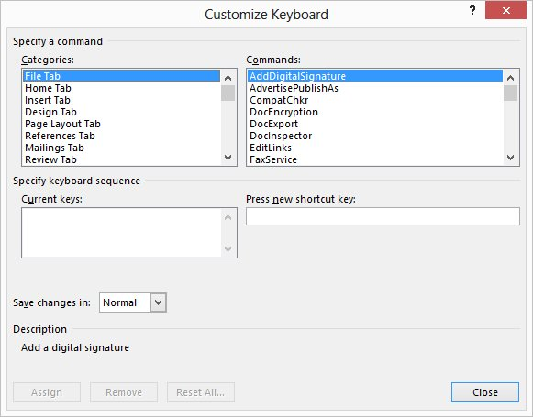
Figure 1. The Customize Keyboard dialog box.
- Scroll through the Categories list and select the Macros category. The list at the right side of the dialog box changes to show the currently available macros.
- In the Macros list, select the macro you want assigned to the shortcut key.
- With the insertion point in the Press New Shortcut Key box, press the shortcut key you want to use. For instance, if you want to use Ctrl+Alt+J, press that.
- Just below the Current Keys box you can see whether the shortcut key is already assigned to a different function.
- Click on Assign.
- Repeat steps 5 through 8 for each change you want to make.
- Click on Close.

