Add sounds, movies, and animations to Microsoft Office PowerPoint 2007 presentations
Learn how-to add video, sound, pictures, and multimedia to presentations and slide shows with Microsoft Office Powerpoint 2007.

Video: Add sounds, movies, and animations
Create compelling media presentations controlling sound or music within a slide show. Students record their own voices, sounds, and movies and insert them into slides to tell a story. Teachers use sound to prompt questions or narrate text. Watch the video

Get started
First, open a presentation you've been working on, or create a new one. Then, move to the slide where you would like to add movies or sound.

To insert a movie (an animated picture) from Clip Organizer:
- On the Insert tab in the Media Clips group, click Movie, and then click Movie from Clip Organizer.
- Scroll through the list, or type keywords in Search for, and then click Go.
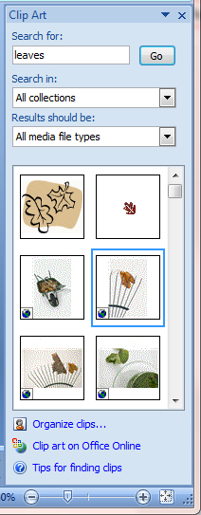
- To preview a clip, point to a thumbnail, and click the arrow that appears. Then, click Preview/Properties.
- To insert the movie into the slide, click the thumbnail.
- Drag the image or use the resize handles on the border to move or resize it.
- Run the slide show to see how the movie looks.

To insert a sound (.wav or .mid file) from Clip Organizer:
- On the Insert tab in the Media Clips group, click Sound, and then click Sound from Clip Organizer.
- Scroll through the list, or type keywords in Search for, and then click Go.
- To preview a sound, point to a clip and click the arrow that appears. Then, click Preview/Properties.
- To insert the sound into the slide, click the thumbnail.
- Choose when you want the sound to play:
  - Automatically. The sound plays automatically when you show the slide.
  - When Clicked. The sound plays during the presentation when you click the sound icon.
  - Move or resize the sound icon just as you would a picture.
  - Select the icon, and click the Sound Tools Options tab for more options.
For example, if your sound runs automatically, you can click Hide During Show in the Sound Options group to hide the icon. Click Slide Show Volume, if you want to lower the volume of the sound to play in the background.
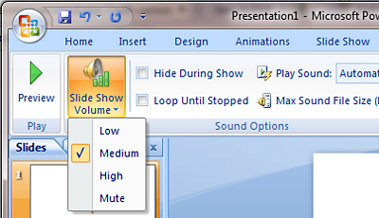

To insert a movie file:
- On the Insert tab in the Media Clips group, click Movie, and then click Movie from File.
- Locate the file using the Insert Movie dialog box.
- Choose when you want the movie file to play:
  - Automatically. The movie plays automatically when you show the slide.
  - When Clicked. The movie plays during the presentation when you click the icon.
  - Move or resize the movie thumbnail just as you would a picture.
  - Select the icon, and click the Movie Tools Options tab for more options.

To record your voice and add it to a slide:
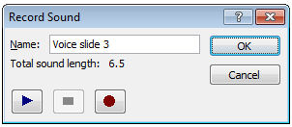
NOTE: To record your voice, you need to have a microphone connected to your computer.
- On the Insert tab in the Media Clips group, click Record Sound.
- Type a name for the recording, or use the default name.
- To begin, click the Record button.
- When you are finished, click the Stop button.
- To listen to the recording, click the Play button. Click the Record button again to add more sound to the recording, or click Cancel to start over at step 1. If you like the recording, click OK.
- A sound icon appears on your slide. You can move or resize the sound icon just as you would a picture. Select the icon, and click the Sound Tools Options tab for more options. While working on your presentation, you can hear the recording at any time by double-clicking the sound icon.

To control a music CD during a slide show:
- Place a music CD in your CD drive. If the CD starts playing, close the media player program.
- In Office PowerPoint 2007, on the Insert tab in the Media Clips group, click Play CD Audio Track.
- In Start at track and End at track, enter the track numbers that you want to start and end with. Also, you can enter times when you want playback to start and end. For example, in the figure shown, the CD will start playing at 4 minutes and 32 seconds into track 5 and will stop playing at 3 minutes and 21 seconds into track 7. To play just one track, enter the same track number in Start at track and End at track. When you are finished, click OK.
- Choose when you want the CD to play:
  - Automatically. The CD plays automatically when you show the slide.
  - When Clicked. The CD plays during the presentation when you click the icon.
  - Move or resize the CD icon just as you would a picture.
  - Select the icon, and click the CD Audio Tools Options tab for more options
IMPORTANT: For Office PowerPoint 2007 to play a track during the presentation, the music CD must be in your drive.

