An Automatic Two Spaces after a Period
Tom asked if there is a way to configure Word so it automatically places two spaces after each period, as can be done in WordPerfect. It is interesting that every time a question about inter-sentence spacing comes up, I receive a flurry of messages indicating either that two spaces is a good idea or that two spaces represents poor form.
I'm not going to get into considerations of what is right or wrong when it comes to spacing between sentences. There are, quite honestly, good reasons to do such spacing, and equally good reasons to not do it. (Tom, I trust you will make your own educated decision about whether two spaces after a period is really necessary in this day and age.)
That being said, the purpose of this tip is to explain how you can adjust your typing for the spacing you prefer. Word does not provide an "automatic two spaces" setting, as is available in WordPerfect. There are still things you can do, however.
First of all, you can configure Word's grammar checker to flag any end-of-sentence spacing that doesn't match your preferences. Simply follow these steps:
- Display the Word Options dialog box. (In Word 2007 click the Office button and then click Word Options. In Word 2010 display the File tab of the ribbon and then click Options.)
- Click the Proofing option at the left side of the dialog box.
- Click the Settings button. Word displays the Grammar Settings dialog box. (See Figure 1.)
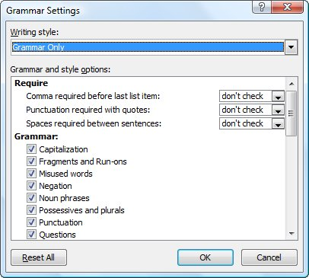
Figure 1. The Grammar Settings dialog box.
- Use the Spaces Required Between Sentences drop-down list to indicate how many spaces you prefer between your sentences.
- Click on OK to close the Grammar Settings dialog box.
- Click on OK to close the Word Options dialog box.
Now the grammar checker will flag any sentences that don't conform to your preference with a green wavy underline. When you then right-click on the flagging, you can choose to correct the spacing for that occurrence.
If you want to do mass replacements of your end-of-sentence spacing, the best thing to do is to use the search and replace features of Word. The techniques to do this have been covered in other issues. For those of you who want to automate the process of using search and replace, the following VBA macro is quite handy. It will replace any number of spaces at the end of a sentence with two spaces:
Sub TwoSpaces()
Selection.Find.ClearFormatting
Selection.Find.Replacement.ClearFormatting
With Selection.Find
.Text = "([.\?\!]) {1,}"
.Replacement.Text = "\1 "
.Forward = True
.Wrap = wdFindContinue
.Format = False
.MatchWildcards = True
End With
Selection.Find.Execute Replace:=wdReplaceAll
End Sub
If you want to alter the macro so that it ensures all your sentences have only a single space at the end, you can simply change the .Replacement.Text line so there is only one space in the replacement string. Another thing to note about this macro is that it corrects any sentences ending in a period, question mark, or exclamation point; it will not catch and correct any sentences that end in a quote mark.
“Finally, just in case you are curious, you cannot effectively use AutoCorrect to change end-of-sentence spacing. Why? Because AutoCorrect uses the space character as a signal to trigger checking what was just typed. Thus, AutoCorrect entries cannot utilize spaces, so you cannot use AutoCorrect to search for a period followed by a space and replace it with a period followed by two spaces. You can, if you desire, cause AutoCorrect to replace every period you type with a period followed by two spaces, but this can lead to some very bizarre typing experiences. Try it, if you want, but you will probably delete the "replace periods with a period and two spaces" entry shortly after the try.

