Animate chart elements in Microsoft Office PowerPoint 2007
Learn how to animate chart elements in Microsoft Office Powerpoint 2007.
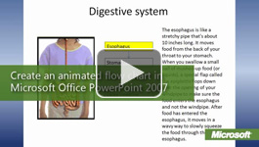

Video: Animate chart elements
Office PowerPoint 2007 animation can help students stay focused in presentations by making them more engaging, adding transitions between slides, animation within slides, simplifying busy charts, and synchronizing each chart section with the discussion. Watch the video

Create your chart in Microsoft Office Excel 2007
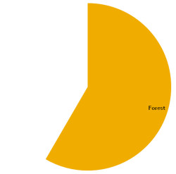
- Select the chart in Excel and then copy and paste it into a PowerPoint slide. Note that by default the chart colors change to match your PowerPoint theme. Also, the chart is linked to your Excel workbook. To modify the chart, select it and then click the Design, Layout, and Format tabs under Chart Tools just as you can in Excel.
- With the chart selected, on the Animations tab in the Animations group, click Custom Animation.
- In the Custom Animation pane, click Add Effect, and select an Entrance effect that works well with your chart. For example, use a Wipe for a bar chart, and a Wedge for a pie chart. You will see that by default the effect reveals the entire chart at once.
- To add animation to individual chart elements, right-click the animation item in the Custom Animation task pane and click Effect Options.
- On the Chart Animation tab, select an item in the Group chart list to determine the order in which the elements are revealed. Next, click OK. During your presentation, you will click the mouse or press the Space Bar to reveal each chart element.
- Under Modify: effect, you can modify the properties of the effect. For example, you can change the direction and speed of a wipe effect. 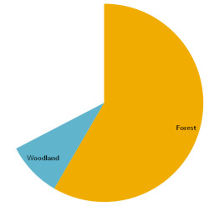
- Click the Play button to preview the animation.

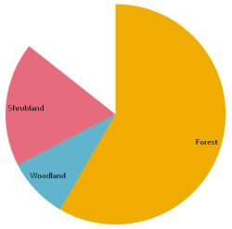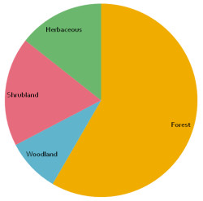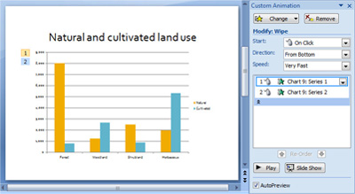

Tip: When you add Chart Animation to each element of a chart, PowerPoint creates separate animations for groups of elements. You can click the down arrows, under the animation item in the Custom Animation pane, to expand the list of grouped elements. To modify animation properties for a group, select an item in the expanded list. For example, you can change the animation effect for the bars in each category or delete the background animation if you want the background to appear without animation.

