Cannot Add Words to Dictionary
Richard notes that when doing a spelling check in the background, Word dutifully underlines words it thinks are spelled incorrectly. However, when he right-clicks on the word in order to add it to the dictionary, he finds the "add to dictionary" option grayed out, so that he cannot add it.
The most likely cause for this situation is that the language of the word you are trying to add doesn't match the language of the dictionary. Word keeps track of the language of both your text and allows you to specify with what language a dictionary should be associated. You can check the language of your dictionary in this manner:
- Display the Word Options dialog box. (In Word 2007 click the Office button and then click Word Options. In Word 2010 display the File tab of the ribbon and then click Options.)
- Click Proofing at the left side of the dialog box.
- Click on the Custom Dictionaries button. Word displays the Custom Dictionaries dialog box. (See Figure 1.)
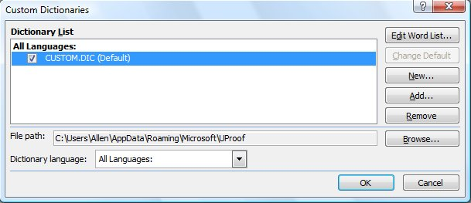
Figure 1. The Custom Dictionaries dialog box.
- In the list of dictionaries, select the one you want to check.
- At the bottom of the dialog box is the Language drop-down list. This should be set to All Languages.
- Close all the open dialog boxes when you are done.
If you have the custom dictionary set to something other than All Languages in step 5, then Word only lets you add words that are in the language you specified. In other words, if you set the language in step 6 to French, then you won't be able to add any words that are in English, German, Spanish, or some other language. You can always set up multiple custom dictionaries and make sure that each of them is configured to the different languages in which you are working.
If the above steps don't solve the problem, then it is possible that you don't have a custom dictionary set up on your system. Of course, if you tried to go through the above steps, you would have noticed fairly easily that there wasn't a custom dictionary—there would have been nothing shown in the Custom Dictionaries dialog box (step 3).
You could also check to make sure that the dictionary is accessible by you and that you have rights to work on it. This potential problem normally only crops up if you are using a custom dictionary on a network and you don't have sufficient permissions to make changes to the file. If you suspect this is an issue in your case, you should talk with your network administrator to get it checked out.

