Centering a Table
By default, Word automatically left-justifies a table in your document. If you want to quickly center the table between the page margins, follow these steps:
- Right-click on the table. Word displays a Context menu.
- Choose Table Properties from the Context menu. Word displays the Table Properties dialog box.
- Make sure the Table tab is selected. (See Figure 1.)
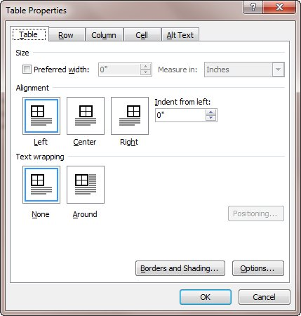
Figure 1. The Table tab of the Table Properties dialog box.
- Click on Center.
- Click on Close.

