Changing Many Link Locations
In a corporate environment, documents are often kept on a network server. That server may not even be close to where you are—it may be across the country or around the world. If you are creating documents that include many graphics, it is common practice to only link to those graphics, and to store the graphics on a network server where they are accessible by everyone using the document.
What happens when the server changes, however? What if the company updates or moves a server, and in the process changes the address at which your graphics are accessed? When linking to graphics over a network, Word keeps track of the graphic's location using a UNC (Universal Naming Convention). If the UNC address of your graphics changes, you need to change the UNC used in the link. It is possible to do this one link at a time, but if you have many, many graphics in a document, this can be a major pain.
There is a quicker way to update the UNC address of a server, however. Let's say that you work for a company, and they change servers, thereby changing the UNC address at which your graphics are accessed. In examining the old and new addresses, you notice that the only thing that changed was the name of one server, from bcdapp to qcyapp. To change all the links in your document to reflect the new server name, follow these steps:
- Open the document in which you want to change the links.
- Change to Draft view. (If you are in Print Layout view, Word tries to repaginate quite often as you try to do the changes, and that makes this whole process much longer.)
- Press Alt+F9 so that field codes are showing. (Links are nothing but field codes, so the full field codes for each of your links should be visible.)
- Press Ctrl+H. Word displays the Replace tab of the Find and Replace dialog box. (See Figure 1.)
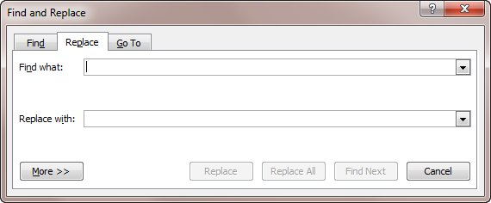
Figure 1. The Replace tab of the Find and Replace dialog box.
- In the Find box, enter the portion of the link you want to change. In the example described above, you would enter bcdapp.
- In the Replace box, enter the new portion of the link. In the example described above, you would enter qcyapp.
- Click Replace All. Word replaces all the text within the exposed links.
- Close the Find and Replace dialog box.
- Press Alt+F9 so that field results are showing. (Your results still won't show properly until you do the next two steps.)
- Select the entire document by pressing Ctrl+A.
- Press F9. Word updates all the fields in the document, including those links you just changed.

