Changing the Bullet Type
Word allows you to easily create bulleted lists in your documents. As a default, Word uses a small dot as the bullet. You can change the bullet to any character you desire. You can change the bullets by following these steps:
- Make sure the Home tab of the ribbon is displayed.
- Locate the Bullets tool within the Paragraph group. Click the down-arrow at the right of the Bullets tool. Word displays a palette of options.
- Select a bullet style from those shown in the Bullet Library portion of the palette.
- If you don't like any of the styles shown, click Define New Bullet. Word displays the Define New Bullet dialog box. (See Figure 1.)
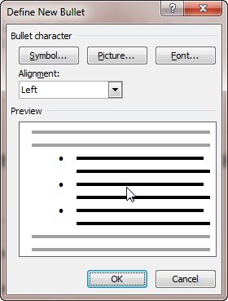
Figure 1. The Define New Bullet dialog box.
- Click the Symbol button. Word displays the Symbol dialog box. (See Figure 2.)
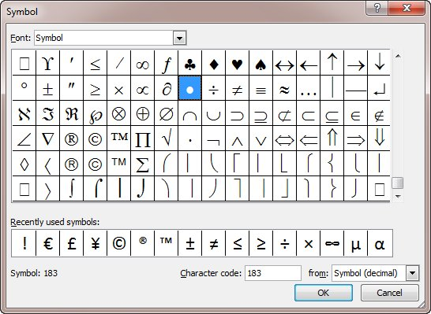
Figure 2. The Symbol dialog box.
- Select a symbol to use as a bullet from among those shown.
- You can select a different set of symbols by selecting a different typeface in the Font drop-down list.
- When you have selected a symbol, click on OK. Word displays the Define New Bullet dialog box again.
- Click on OK to close the dialog box.

