Changing the Starting Page Number
Word gives you quite a bit of flexibility in working with page numbers. There may be times when you want to change the starting page number for a particular part of your document. For instance, your document may include a couple pages of preliminary information, but you want the actual page numbering to start on the third physical page. This is quite easy to do in Word.
Page numbering can be varied by section in your document. Thus, to change the way in which pages are numbered in the previous scenario, you would perform the following steps:
- Position the insertion point at the end of the second physical page in your document.
- Display the Page Layout tab of the ribbon.
- In the Page Setup group, click Breaks and then click Next Page. The section break appears in your document, and the text following the break will begin at the top of a new page.
- Display the Insert tab of the ribbon.
- With your insertion point located on the third physical page (in other words, right after the section break you added), click Page Number in the Header & Footer group, and then click Format Page Numbers. Word displays the Page Number Format dialog box. (See Figure 1.)
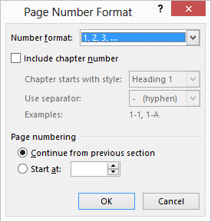
Figure 1. The Page Number Format dialog box.
- In the Page Numbering area of the dialog box (at the bottom), click on the Start At radio button and indicate the starting page number for the section.
- Click on OK to close the Page Number Format dialog box.
At this point you can add your page numbers as you normally would. For most people this means changing the header or footer to include the page number. Remember, as well, that headers and footers can vary by section of your document. Thus, this new section can include the page number in the header or footer, and the previous section can omit it.

