Comments Only Visible When Hovering Over a Word or Phrase
In Excel Satish can add a comment to a cell that is only visible when the user hovers the mouse pointer over that cell. He wants to do the same sort of thing in Word, such that when he adds a comment to a selected word or phrase, the comment is only visible when the user hovers the mouse pointer over that word or phrase.
There is a "sort of" way to do this using comments, but it may not yield exactly what you are looking for. Follow these steps if you are using Word 2007 or Word 2010:
- Display the Review tab of the ribbon.
- In the Tracking group, click the Track Changes drop-down list.
- Choose Change Tracking Options. Word displays the Track Changes Options dialog box. (See Figure 1.)
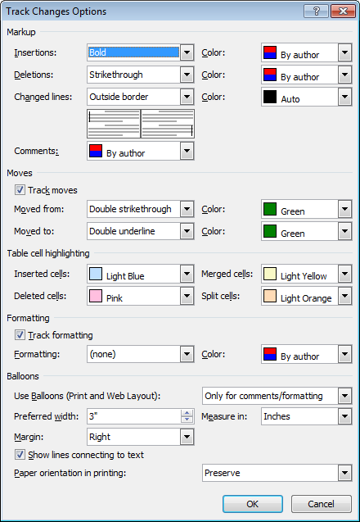
Figure 1. The Track Changes Options dialog box in Word 2010.
- In the Balloons section, click the Use Balloons drop-down list and choose Never.
- Click OK to close the dialog box.
If you are using Word 2013, follow these steps, instead:
- Display the Review tab of the ribbon.
- Click the Display for Review drop-down list (in the Tracking group) and choose All Markup.
- Click the small icon at the bottom-right of the Tracking group. Word displays the Track Changes Options dialog box. (See Figure 2.)
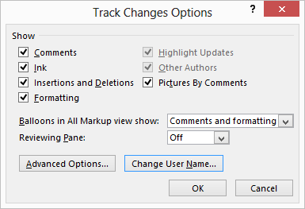
Figure 2. The Track Changes Options dialog box in Word 2013.
- Click the Balloons in All Markup View Show drop-down list and choose the Nothing option.
- Click OK to close the dialog box.
Regardless of the version of Word you are using, you can continue to add comments as you normally would. The contents of the comment won't appear until you hover the mouse over the word or phrase you marked with the comment. (You can tell which words or phrases have comments because they are highlighted in a color keyed to the user who created the comment.)

