Controlling Overtype Mode
Word has two different editing modes you can use—insert mode and overtype mode. When insert mode (the default) is active, the information you type is inserted at (where else?) the insertion point. When overtype mode is active, information isn't inserted, but replaces whatever is to the right of the insertion point.
Word doesn't let you know, by default, if you are using overtype mode or not. The easiest way to tell is if, when you type, each character you type replaces a character previously in the document. You can also configure Word to display an indicator on the status bar. Right-click a blank spot on the status bar. Word displays a large list of items that can appear on the status bar. Each item that has a check mark next to it has a place on the status bar; if there is no check mark, then that item is excluded. You want to click the Overtype item so that it has a check mark. An indicator immediately appears near the left side of the status bar consisting either of the word Insert or Overtype. (By this point you can probably figure out what each word means.)
To control switching between insert and overtype modes, follow these steps:
- Display the Word Options dialog box. (In Word 2007 click the Office button and then click Word Options. In Word 2010 and Word 2013 display the File tab of the ribbon and then click Options.)
- At the left of the dialog box click Advanced. (See Figure 1.)
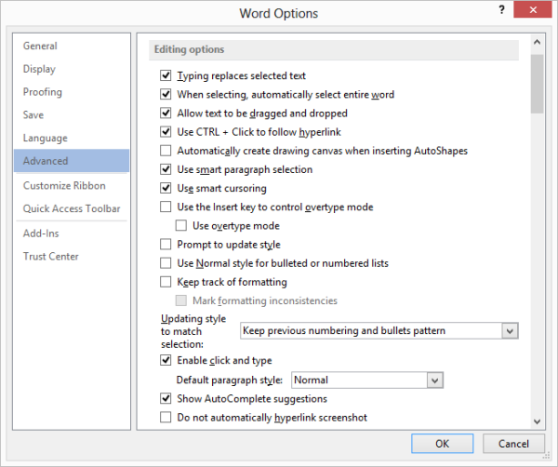
Figure 1. The advanced options of the Word Options dialog box.
- Click on the Use Overtype Mode check box. (It is in the Editing portion of the options list.) If the check box is clear, then overtype mode is turned off and insert mode is active.
- Click on OK.
While you've got the dialog box open, you should also think strongly of choosing the Use the Insert Key to Control Overtype Mode option. With the option selected, the Insert key on your keyboard toggles between insert and overtype modes.

