Create a class newspaper with Microsoft Office Publisher 2007
Learn how to use Microsoft Office Publisher 2007 to create and publish projects such as a class newspaper.
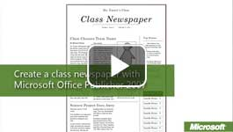

Video: Create a class newspaper
Students benefit from collaborative projects that develop team-building and problem-solving skills such as a class newspaper. Microsoft Office Publisher 2007 helps quickly and inexpensively publish a newspaper, giving students time to write creatively. Watch the video

Collaborative work
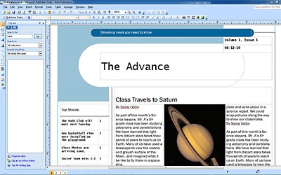
You can divide your class into small working teams that rotate through the various tasks required to publish a newspaper. For example, one team can be responsible for writing stories, another team for taking and sourcing pictures, and another for handling the layout. Publisher provides all of the functionality required for students to create a well-designed newspaper and automates a lot of the details. For example, Office Publisher 2007 automatically resizes heading text to fit the space and flows text from one text box to another.

Create a template
- Start Office Publisher. In the Publication Types list, click Newsletters. Click a newsletter template. For more choices, click View templates from Microsoft Office Online. Don't worry about finding the perfect template–you can change any aspect of the design later. 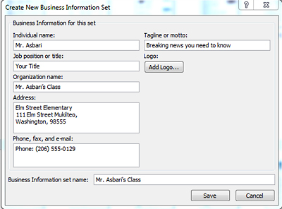
- In the preview pane on the right, you can modify the color and font schemes.
- Click Business Information, and enter details about the class and the newspaper. Information that you enter here will appear in various locations of the template.
- Click Create, and a new publication is built from the template.
- Before you begin your first edition, modify the boilerplate elements of your publication to create a custom template. Click the placeholder text in the title text box, and type the name of your newspaper. Click the border of any text box or object to move it to a new location or to resize or delete it. In the Task pane, select Format Publication, and modify the options that will affect the overall design. You can even change the template.
- On the File menu, click Save. Under Save as type, select Publisher Template (*.pub), enter a name for the template, and then click Save.

Publish your first edition
- Start Publisher, or, on the File menu, click New.
- In the list on the left, click My Templates, and double-click your newspaper template.
- In the new publication, do any of the following:
- Add text:
  - Click to select placeholder text, and then start typing. The text boxes are already formatted with the font scheme you chose for your template.
  - If a story was submitted by a writer as a Microsoft Office Word document, copy the contents of the document to the clipboard. Then, in Office Publisher, select the placeholder text, and click Paste. 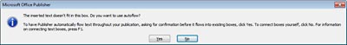
  - When a text box cannot hold any more text, Office Publisher displays a message with your options.
If you click No, the editorial team can edit the text to fit the space or you can increase the size of the text box. Click Yes if the editors decide the story deserves more space. Then, follow the instructions in the next message to select a text box into which you want the excess text to flow. This feature, called autoflow, helps you to quickly adjust the layout of your newspaper.
- Add pictures:
  - Click a picture placeholder. In the Picture toolbar, click the Insert Picture button, browse for the picture, and click Insert.
  - Click the Text Wrapping button on the Picture toolbar to choose how you want text to wrap around the picture.
- Change the layout:
  - To move an object, such as a text box or picture, drag the border. To resize an object, drag the resize handles (the small circles) on the border or corners.
  - To add an object, click the Insert menu, and select the object. If the cursor changes to cross hairs after selecting an object, such as a text box, drag to draw the object on a page.
  - If you plan to print on both sides of the paper and your publication template is set up for two-sided printing, you can view the inside pages as your readers will see them—two at a time. On the View menu, click Two-Page Spread. Notice that many of the newsletter templates use mirrored layouts. For example, the page number is placed in the upper-left corner on even pages and in the upper right on odd pages.
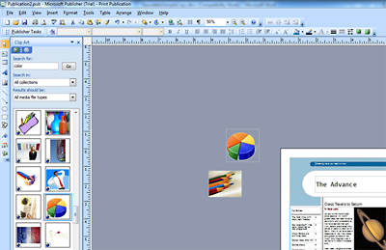
Tip: To help you lay out your pages, you can store objects in the space outside the publication area. For example, to help you decide which picture to use and where to use it, you can store all of the pictures in the workspace outside the newspaper and then drag pictures onto the layout to see how they look.

