Create a pictograph using Microsoft Office Excel 2007
Show your students how to make a pictograph with Microsoft Office Excel 2007.
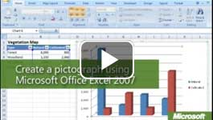

Video: Create a pictograph
You can make it easier for students to understand data relationships by converting them into a pictograph—a graph with pictures. Office Excel 2007 stretches or stacks pictures to represent the values being graphed. Watch the video

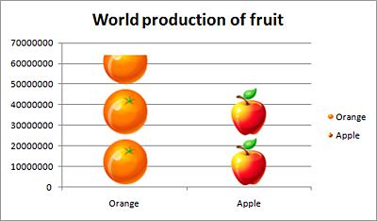
In Office Excel 2007, you can use pictures to explain data relationships.

Examples of pictographs
The following example shows how pictures can be used to compare trends such as the amount of apples grown worldwide versus oranges.

How to create a pictograph
- Enter your data into a worksheet or table, and then select the data. Include the field headings and title.
- On the Insert tab in the Charts group, select a chart. Choose a chart with elements that can support a picture (a bar chart, for example).
- In the chart, select the first element to which you want to add a picture, and then double-click the element. The picture will be inserted in all the elements that are selected, so make sure that the selection border is around only the first element.
- In Chart Tools, click the Format tab, and then, in the Current Selection group, click Format Selection.
- In the Format Data Point dialog box, in the left navigation pane, click Fill. 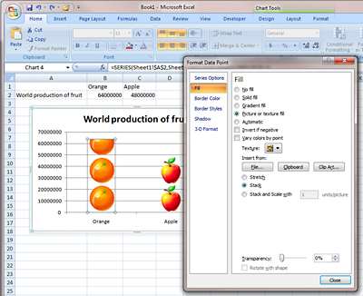
- In the right pane, click Picture or texture fill.
- Under Insert from, browse for a picture file or clip art image, or insert the contents of the clipboard.
- Choose whether to Stretch or Stack the image.
- Repeat steps 3 through 8 for each of the other elements.

