Create a timeline using Microsoft Office Excel 2007
Design a visual representation of important events or lesson plans using Microsoft Office Excel 2007.
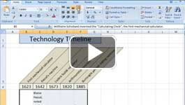

Video: Create a timeline
Show your students how events relate over time by laying out information along a timeline. Demonstrate progress, support themes and ideas, summarize details, and help students visualize trends. Timelines let students see and understand the big picture. Watch the video

What to put in a timeline
Text, SmartArt graphics, and pictures offer you visual elements for a timeline. Use the Office Excel 2007 grid to accurately layout and align the elements. Younger students can even build a timeline with pictures instead of words. These samples and step-by-step instructions will give you an idea of what can be done.

Sample timelines
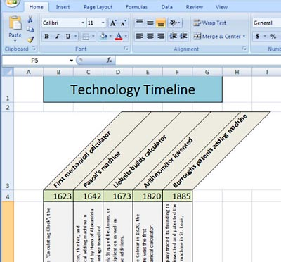
You can add cell colors and angled text to your timeline.
This timeline uses angled text within cells, borders around the cells, and cell fill colors.
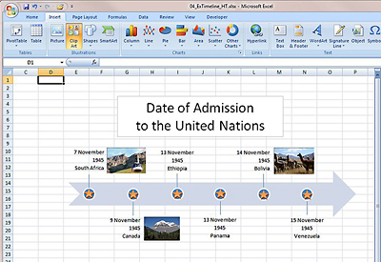
Try using callout shapes and clip art to enhance your timeline.
This timeline uses callout shapes, cell fill colors, and clip art. To add a callout, on the Insert tab in the Illustrations group, click Shapes, and then select a callout or any of the other shapes. Then, type a caption.
Two variations on these timelines:
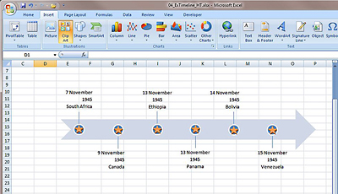
You can build a timeline with SmartArt.
This timeline was created with SmartArt. You can choose a pre-built SmartArt timeline framework that includes all of the graphical elements and then add your text. You can further customize the look of a timeline by applying a SmartArt style.

Create a basic timeline
- Plan your timeline: Do your research, and then sketch out a timeline on paper.
- Start Excel with a new, blank worksheet.
- Add a title across the top of the worksheet, and format the text.
- Place dates or times in a row, several rows below the title. Format the dates now, or wait until you have entered all of the data.
- Type short descriptions in the row above or below the date or time.
- Orient the description at an angle to conserve horizontal space. Select the text. Then, on the Home tab, in the Alignment group, click the Orientation button and select an angle. For more choices, click Format Cell Alignment to open the Format Cells dialog box. In the Orientation box, drag the line next to Text up or down, or enter a number in the Degrees box to set the angle manually.
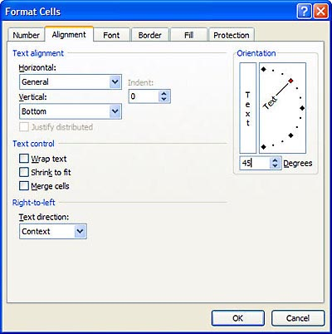
Tip: To save time, you can format groups of cells instead of each individual cell. For example, if you select all of the description cells and then choose an orientation angle, the formatting will be applied to all selected cells at the same time. You can also save time by using the Format Painter. Format one cell the way you want it. Then, select the cell and, on the home page in the Clipboard group, click the Format Painter button. To apply that same formatting to one or more additional cells, click and drag across the cells.
- Add a picture, shape, or clip art. On the Insert tab, in the Illustrations group, click Pictures, and select a file on your computer. Or click Clip Art, and then, in the Clip Art task pane, select Clip Art from the gallery installed on your computer or the from the Microsoft Office Online website. Or click Shapes, and select a shape. Then, drag the image or shape to position and resize it. Select the shape and start typing to add text to it.
- Apply additional formatting, such as font type and size, color, and styles, to the elements in your timeline. For more options, on the Home tab in the Cells group, click Format, and then click Format Cells. Here you can access cell formatting details. On the Border tab, you can add or remove borders, add border colors, and choose a line style.
- Adjust the width of columns and height of rows. Use the Format Cells dialog box to enter sizes manually, or drag the border between column or row headings. Select multiple rows or columns to change the sizes of all those selected at the same time.
- Add color to cells. Select the cells you want to color. Then, on the Home tab in the Font group, click the Fill Color button, and select a color.

Create a timeline with SmartArt
- On the Insert tab, in the Illustrations group, click SmartArt.
- In the Choose a SmartArt Graphic dialog box, in the left navigation pane, click Process.
- In the center pane, select a timeline thumbnail. The right pane displays the details of the selected thumbnail.
- Click OK.
- Position and resize the graphic by dragging the border, or resize areas (the dotted areas on the border).
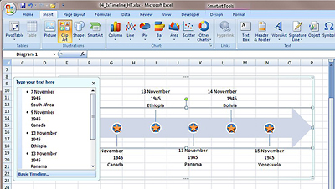

- To add text, click a text placeholder and start typing, or click the arrows on the left border and type text into the text entry box.
- To add formatting and styles, select the SmartArt graphic and then select options on the SmartArt Tools Design and Format tabs.

