Create an animated flow chart in Microsoft Office PowerPoint 2007
Learn how to add an animated flow chart to presentations using Microsoft Office PowerPoint 2007.
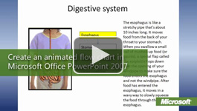

Video: Animate chart elements
Office PowerPoint 2007 animation can help students stay focused in presentations by making them more engaging, adding transitions between slides, animation within slides, simplifying busy charts, and synchronizing each chart section with the discussion. Watch the video

​Animate a flow chart
Follow the steps in this article to animate a flow chart that demonstrates the function of the digestive system. Before beginning their flow charts, students can research their chosen human body system and locate, copy, and save images to be used in the presentation.
You can either add an animated flow chart to a slide show as you're creating it, or you can instruct your students to add animation as part of the lesson later.

Create a template for content that appears on all slides
All of the parts that don't change in the animation are added to a custom layout slide in the Slide Master.
The custom layout is the template on which you add all of the other parts. One advantage to using a custom layout is that when you make changes to it, all of the slides that use the layout are automatically updated.
- Open a blank presentation in Office PowerPoint 2007.
- On the View tab, in the Presentation Views group, click Slide Master.
- On the Slide Master tab, click Insert Layout. A new layout appears in the work area and is added to the slide thumbnail pane.
- In the Master Layout group, clear the Title and Footers check boxes.
- In the Edit Master group, click Rename, and then type a new name, such as Digestive system.
- On the Insert tab, click Text Box, and draw a text box at the top of the slide. Then, type a title for the flow chart. In this sample, the title is Digestive system.
- Click outside the title, and then, on the Insert tab, in the Illustrations group, click Picture.
- Locate the picture of the digestive system, and click Insert.
- Move and resize the picture to fit on the left side of the slide.

Add the flow chart to the template
- On the Insert tab, in the Text group, click Text Box, and draw a small text box (even with the top of the picture).
- Click Shape Outline, and select an outline color.
- Press CTRL+C, and then press CTRL+V to create a copy of the text box.
- Create a column by dragging the copy to position it below the first text box.
- Repeat steps 3 and 4 to add as many text boxes as you need for your flow chart. In this sample, there are five text boxes.
- Select the text boxes, click Align, and then click Distribute Vertically to space the text boxes evenly. Then, click Align, and click Align Center. You can resize or move the picture if it is covered by the text boxes.
- In each text box, type the name of the associated step in your process, starting with the topmost text box.

Add arrows to the flow chart
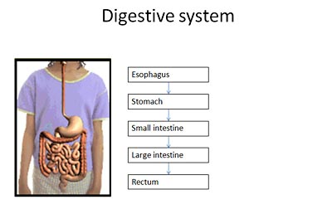
- On the Insert tab, in the Illustrations group, click Shapes, and then select the line with one arrow.
- Move the mouse pointer over the top text box. Red connection points appear. Drag the connection point on the bottom of the text box to the connection point on the top of the next text box. When you release the mouse button, the line is added between the text boxes.
- With the line still selected, press CTRL+C, and then press CTRL+V to create a copy.
- Drag the new line to connect the second and third text boxes. After positioning the line, you can drag the top and bottom points of the line to snap them to connection points on the text boxes.
- Continue copying and aligning lines until all of the text boxes are linked.
- On the Slide Master tab, click Close Master View.

Add slides for each step in the process
With the new layout template created, you return to Normal view and use the new layout to add content to individual slides.
- On the Home tab, in the Slides group, click the arrow next to New Slide, and then select the new layout (Digestive system).
- On the Insert tab, click Text Box, and then draw a text box over the top of the first text box.
- In the new text box, type the same text as that of the text box it is covering (for example, Stomach). Then, on the Drawing Tools Format tab, add a Shape Outline and yellow Shape Fill.
- In the slide thumbnail pane, right-click the slide and then click Duplicate Slide.
- In the new slide, drag the yellow text box down to position it over the next text box, and then change the text to that of the text box it is covering. 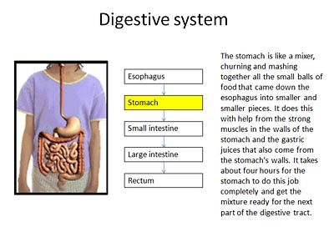
- Repeat steps 4 and 5 to add slides for each step in the process.
- Go back to the first slide, draw a text box to the right of the flow chart, and then type information that explains the function and process of the first step of your flow chart.
- Repeat step 7 to add details to the other slides.
- When you change from one slide to the next, the yellow highlight will appear to move to the next box in the flow chart as the detail text changes. Because you are building the slides on top of a template layout, all other parts of the slides stay perfectly aligned.

Add animation to the Esophagus slide
- You can create a colored line that represents food, and then add Office PowerPoint 2007 animation to show how the food moves through the digestive system. The following sections describe the process for adding animation to the Esophagus and Stomach slides in the example. After you finish the sections, you can create animation for the other parts of the flow chart.
- Select the Esophagus slide.
- On the Insert tab, in the Illustrations group, click Shapes, and then select the line.
- Draw a line that extends the length of the esophagus in the diagram. (That's the tube that runs down from the top of the image.)
- On the Drawing Tools Format tab, in the Shape Styles group, click the dialog box launcher. Click Line Color, and select yellow or another bright color. Click Line Style, and increase the Width to 4 pt. In Dash type, select the Round Dot. Click Close.
- On the Animations tab, click Custom Animation.
- Select the line, click Add Effect, point to Entrance, click More Effects, and then click Wipe. You will see a preview of the effect on the slide. Click OK. The dotted line appears to move upward. To fix that, in the Direction list, select From Top.
- In the Custom Animation task pane, in the Start list, select With Previous. The Entrance effect will occur as soon as the slide appears. You can also adjust other settings for the effect.
- Select the line, click Add Effect, point to Exit, click More Effects, and then click Wipe. Click OK.
- In the Direction list, select From Top, and in the Start list, click After Previous.
- At the bottom of the Custom Animation task pane, click Play. The Entrance effect draws the line from top to bottom, and the Exit effect then erases the line from top to bottom, so it appears that food is going down the esophagus into the stomach.

Add animation to the Stomach slide
To simulate the food being processed in the stomach, you will use a Motion Paths effect. With this type of effect, an object follows a path that you draw or select. We will first draw a small oval to represent food, and then we'll create the motion path.
- Select the Stomach slide.
- On the Insert tab, in the Illustrations group, click Shapes, and then select the Oval.
- Draw a small oval where the esophagus connects to the stomach. On the Drawing Tools Format tab, click Shape Fill, and select yellow. Then, click Shape Outline, and select No Outline.
- On the Animations tab, click Custom Animation.
- In the Custom Animation task pane, click Add Effect, point to Motion Paths, point to Draw Custom Path, and then click Scribble.
- Starting on the yellow oval, draw a long squiggly line inside the stomach, ending where the food exits the stomach. The preview shows the oval following the motion path.
- Click the Start list, and select With Previous. Then, modify other properties, as needed, on the Custom Animation task pane.

