Create datasets with Microsoft Office Excel 2007
Learn how to use Microsoft Office Excel 2007 for data collection and analysis.
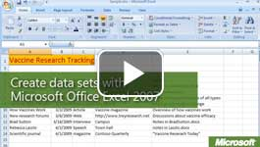

Video: Create datasets
Understanding research and data collection methods is an essential tool for learning. Microsoft Office Excel 2007 can help you collect, manage, track, and organize datasets of any size. Watch the video

Organize and understand data
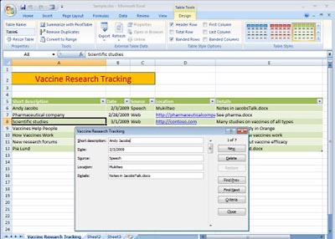
Tables can be used to track research.
Tables and datasets can help you track, find, and organize large amounts of data. After you become familiar with tables in Office Excel 2007, you can explore many ways to manage data, such as sharing it over a network and creating forms with Microsoft Visual Basic (which is built into Office Excel 2007).
You can even track your research in a table, as shown in the following figure. To make it easier to work with the data, you can use the Form tool to view and enter information in a form.

To create a data set
The following steps show you how to create a table to hold your data, activate the Form tool, and then use the table and Form tool to enter data.

To create a table
- Choose a row for the header row (the top row of the table), and type the field names for your table. You can start the header in any cell of a worksheet, but all of the fields in the header must be in adjacent cells on the same row. 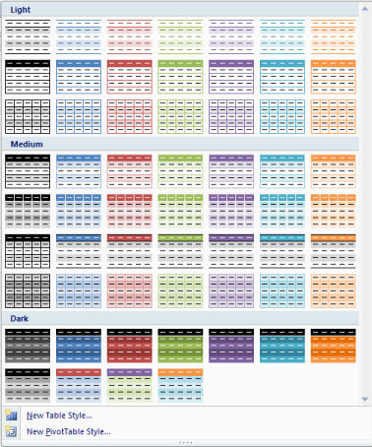
- Drag to select the field names in the header.
- On the Home tab, in the Styles group, click Format as Table.
- Select a table style, or create a custom table.

To activate the Form tool
- Click the Customize Quick Access Toolbar arrow to the right of the Quick Access toolbar in the title bar at the top of the Office Excel 2007 window.
- Click More Commands.
- In the Excel Options dialog box, click Choose commands from, and then select All Commands.
- In the list, select Form, click Add, and then click OK. The Form command is added to the Quick Access toolbar.

To use the table and Form tool
- In your new table, start adding data in the row just below the header. You can select a cell with the mouse pointer or simply press TAB to move right to the next cell. When you reach the end of a table row, press TAB or ENTER to move to the first cell in a new row.
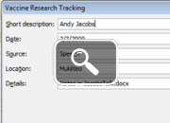
- To enter data with the Form tool, select any cell in the table.
- Click the Form button in the Quick Access toolbar.
- Click New to start a new row, and then type data in the fields. Click New to add more rows of data. When you're finished, click Close.
Tip: To quickly sort and filter the data in your table, click the arrows in the header row. After you feel comfortable with tables, you can explore the tools and commands on the Data tab. For example, you can use Data Validation to restrict the type of data entered in a field. If your table has a date field, for example, Data Validation can be used to make sure that users enter only valid date values. The Data tab also has commands for filtering, sorting, and grouping data.

